Prof. Dinesh Kumar Tripathi Memorial Award
Department of Mechanical Engineering, NIT Raipur

Prof. Dinesh Kumar Tripathi, S/0 Shri S.D. Tripathi joined the Department of Mechanical Engineering, Government Engineering College Raipur in 1989 and served the institute till his sudden demise in the month of September 2009.
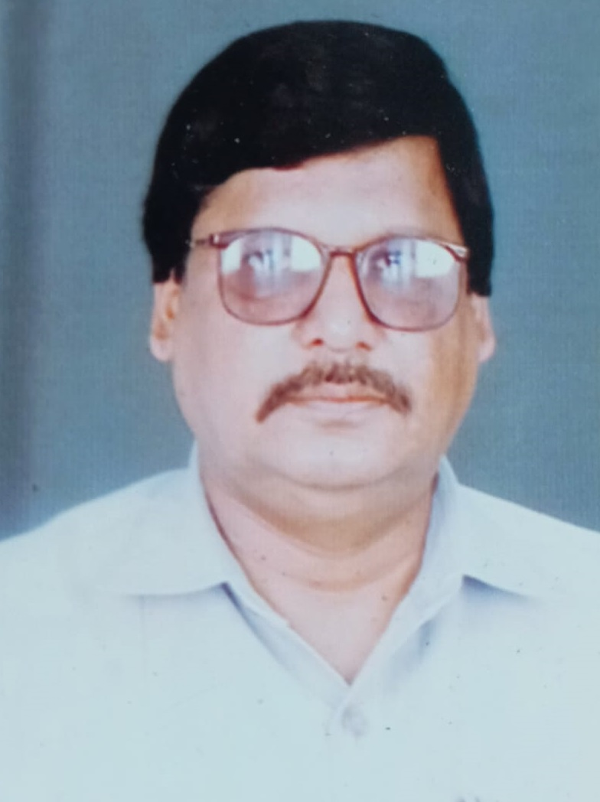
Shri Dinesh Kumar Tripathi was born in Dharamjaigarh (Raigarh). He did his B.Tech. from G.E.C. Bilaspur, M. Tech. in Cryogenic Engineering from IIT Kharagpur and was pursuing his Ph.D. from MNNIT Allahabad (on Cryogenic Air Separation Plants). He was a person full of life, an avid traveller, fond of singing and poetry, passionate about the profession of creating future engineers, he would often say "We are building those, who will build the nation".
Alumni of Mechanical Engineering Department bestow Prof. D. K. Tripathi Memorial Award under different categories to UG students of the Department. This award was initiated by his students Ms. Neha Sonkar, Ms. Monika Naidu, Ms. Nupur Nigam, Ms. Parul Chandak, Ms. Shreya Mishra, Ms. Roshani Pratima, Mr. Sachin Ahuja, Mr. Styaprakash Verma and Mr. Charles Vicky Tigga in his memory since 2012. The awardees are identified every year on the basis of merit and is awarded with certificates along with a prize money.
List of Awardees
S.No. | Year | Name | Category | CPI/ Percent
1. | 2021 | Palak Jain (1st Year) | GEN | 9.29
2. | 2021 | Chetna Burde (1st Year) | OBC | 9.64
3. | 2021 | Rapa Venkata Sai (1st Year) | SC | 9.41
4. | 2021 | Jyotirmoy Ghosh (2nd Year) | GEN | 9.58
5. | 2021 | Tekeshwar Sahu (2nd Year) | OBC | 9.39
6. | 2021 | Aniruddh Kerketta (2nd Year) | ST | 9.16
7. | 2021 | Hrishi Sharad Pinjan (3rd Year) | GEN | 9.47
8. | 2021 | Malikram Patel (3rd Year) | OBC | 9.18
9. | 2021 | Surjeet Kumar Bhargav (3rd Year) | SC | 8.84
10. | 2021 | Kashish Awal (4th Year) | GEN | 9.17
11. | 2021 | Mousam Jaiswal (4th Year) | OBC | 8.80
12. | 2021 | Pawan Kumar Prasad (4th Year) | SC | 8.39
13. | 2020 | Jyotirmoy Ghosh (1st Year) | GEN | 9.97
14. | 2020 | Rashmi Sahu (1st Year) | OBC | 9.60
15. | 2020 | Aniruddh Kerketta (1st Year) | ST | 9.56
16. | 2020 | Hrishi Sharad Pinjan (2nd Year) | GEN | 9.41
17. | 2020 | Malikram Patel (2nd Year) | OBC | 9.08
18. | 2020 | Surjeet Kumar Bhargav (2nd Year) | SC | 8.52
19. | 2020 | Sparsh Tiwari (3rd Year) | GEN | 9.08
20. | 2020 | Mousam Jaiswal (3rd Year) | OBC | 8.64
21. | 2020 | Pawan Kumar Prasad (3rd Year) | SC | 8.36
22. | 2020 | Poorvi Agrawal (4th Year) | GEN | 9.71
23. | 2020 | Bangaru Ramcharan (4th Year) | OBC | 9.11
24. | 2020 | Ganesh Das (4th Year) | SC | 8.54
25. | 2019 | Hrishi Sharad Pinjan (1st Year) | GEN | 9.56
26. | 2019 | Malikram Patel (1st Year) | OBC | 9.14
27. | 2019 | Surjeet Kumar Bhargav (1st Year) | SC | 8.88
28. | 2019 | Piyush Kumar (2nd Year) | GEN | 9.11
29. | 2019 | Mousam Jaiswal (2nd Year) | OBC | 8.65
30. | 2019 | Pawan Kumar Prasad (2nd Year) | SC | 8.42
31. | 2019 | Poorvi Agrawal (3rd Year) | GEN | 9.73
32. | 2019 | Rup Narayan Pal (3rd Year) | OBC | 9.06
33. | 2019 | Ganesh Das (3rd Year) | SC | 8.48
34. | 2019 | Nagare Shubham Maharudra (4th Year) | GEN | 9.30
35. | 2019 | Ajay Kumar Gupta (4th Year) | OBC | 9.07
36. | 2019 | Anshu Kumar Banjare (4th Year) | SC | 8.70
37. | 2018 | Prashant Singhal (1st Year) | GEN | 9.38
38. | 2018 | Mousam Jaiswal (1st Year) | OBC | 8.93
39. | 2018 | Yashwant Kothale (1st Year) | SC | 8.32
40. | 2018 | Poorvi Agrawal (2nd Year) | GEN | 9.68
41. | 2018 | Rup Narayan Pal (2nd Year) | OBC | 9.09
42. | 2018 | Ganesh Das (2nd Year) | SC | 8.42
43. | 2018 | Amit Kumar Singh (3rd Year) | GEN | 9.38
44. | 2018 | Ajay Kumar Gupta (3rd Year) | OBC | 9.03
45. | 2018 | Anshu Kumar Banjare (3rd Year) | SC | 8.64
46. | 2018 | Sanket Kumar (4th Year) | GEN | 9.52
47. | 2018 | Ila Sahu (4th Year) | OBC | 9.19
48. | 2018 | Jatin Singh Netam (4th Year) | ST | 8.65
49. | 2017 | Poorvi Agrawal (1st Year) | GEN | 9.72
50. | 2017 | Rup Narayan Pal (1st Year) | OBC | 9.19
51. | 2017 | Amit Kumar Singh (2nd Year) | GEN | 9.7
52. | 2017 | Sourav Kumar (2nd Year) | OBC | 8.93
53. | 2017 | Sanket Kumar (3rd Year) | GEN | 9.57
54. | 2017 | Ila Sahu (3rd Year) | OBC | 9.30
55. | 2017 | Poojyapreet Patel (4th Year) | GEN | 9.31
56. | 2017 | Jayant Kumar Verma (4th Year) | OBC | 9.24
57. | 2016 | D.Sai Amarnath (1st Year) | GEN | 9.67
58. | 2016 | Sourav Kumar (1st Year) | OBC | 9.29
59. | 2016 | Sanket Kumar (2nd Year) | GEN | 9.43
60. | 2016 | Ila Sahu (2nd Year) | OBC | 9.06
61. | 2016 | Poojyapreet Patel (3rd Year) | GEN | 9.35
62. | 2016 | Jayant Kumar Verma (3rd Year) | OBC | 9.24
63. | 2016 | Ojase Jain (4th Year) | GEN | 9.60
64. | 2016 | Sanjay Kumar (4th Year) | OBC | 9.34
65. | 2015 | Divyanjali Jaiswal (1st Year) | GEN | 9.51
66. | 2015 | Rao Aditya Vikram Singh (1st Year) | OBC | 9.20
67. | 2015 | Pojyapreet Patel (2nd Year) | GEN | 9.30
68. | 2015 | Jayant Kumar Verma (2nd Year) | OBC | 9.30
69. | 2015 | Ojase Jain (3rd Year) | GEN | 9.61
70. | 2015 | Mohsin Khan (3rd Year) | OBC | 9.28
71. | 2015 | Prabhat Kumar Singh (4th Year) | GEN | 84.9
72. | 2015 | Chitrasen Patel (4th Year) | OBC | 83.0
73. | 2014 | Priyanshu Thakur (1st Year) | GEN | 9.14
74. | 2014 | Jayant Kumar Verma (1st Year) | OBC | 9.38
75. | 2014 | Tarun Kaushik (2nd Year) | GEN | 9.51
76. | 2014 | Mohsin Khan (2nd Year) | OBC | 9.17
77. | 2014 | Prabhat Kumar Singh (3rd Year) | GEN | 84.9
78. | 2014 | Chitrasen Patel (3rd Year) | OBC | 83.3
79. | 2014 | Abhijit Jijaba Kalbhor (4th Year) | GEN | 82.1
80. | 2014 | Sourabh Kannoje (4th Year) | OBC | 78.9
81. | 2013 | Prabhat Kumar Singh (2nd Year) | GEN | 84.6
82. | 2013 | Chitrasen Patel (2nd Year) | OBC | 81.9
83. | 2013 | Kanchanbala Sahu (3rd Year) | GEN | 81.8
84. | 2013 | Satish Dayal Yadav | OBC | 77.9
85. | 2013 | Ayush Saraswat (4th Year) | GEN | 84.3
86. | 2013 | Vinay Kumar (4th Year) | SC | 83.6
87. | 2012 | Kanchanbala Sahu (2nd Year) | GEN | 79.8
88. | 2012 | Sourabh Kannoje (2nd Year) | OBC | 79.5
89. | 2012 | Ayush Saraswat (3rd Year) | GEN | 85.2
90. | 2012 | Vinay Kumar (3rd Year) | SC | 83.8
91. | 2012 | Sumit Singh (4th Year) | GEN | 86.9

