Electrical Engineering Association Activities - September 2021
- Virtual Teacher’s Day Celebrations 2021 on 06/09/2021
To relive the students from mental stress and promote Student-Teacher interaction, Electrical Engineering Association of EED has organized virtual meet to celebrate Teacher’s day ‘2021
Date and Time: 06/09/2021 from 3:00 PM to 4:30 PM.
 | 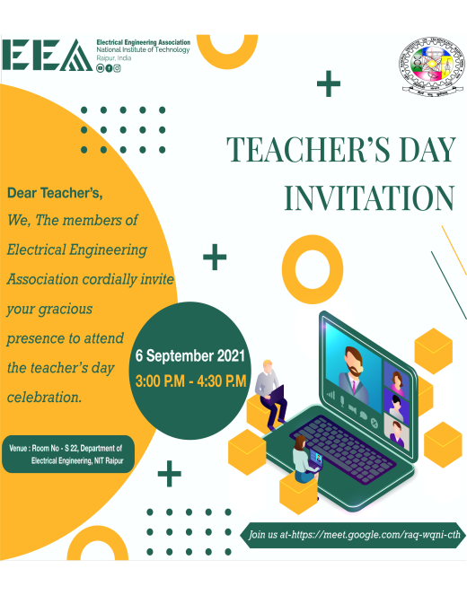
- All the faculty members of the EED gathered in Room No: S-22
- Live video is streamed with the students. Session is also steamed online via YouTube.
- Around 100 students attended online: Google meet link https://meet.google.com/raq-wgni-cth.
- Faculties are felicitated by students with token of respect.
- Students showcased their creativity through various modes activities like singing, dance, poetry and shared their boundless emotions created by pandemic.
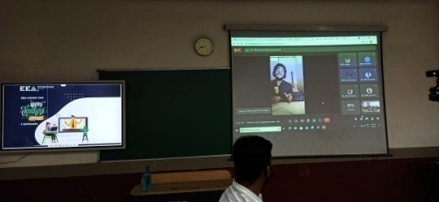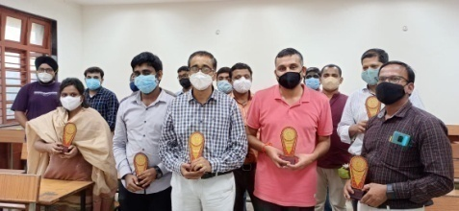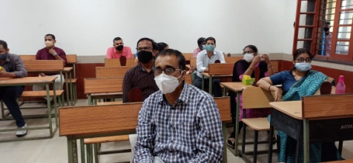

Electrical Engineering Association Activities - September 2021
2. Engineers Day celebration & Inaugural of Electrical Engineering Association on 15/09/2021.
Mode of conduction : Virtual
Tentative date: Engineers Day – 15th Sep’ 2021
Event details: Engineers Day celebrations- Alumni interaction, EEA Inaugural Executive body of EEA for the academic year 2021-22.
- To celebrate Engineers Day by evoking the key essence of Engineering, Electrical Engineering Association (EEA) of Department of Electrical Engineering (EED) is organizing a virtual meet for the students and faculty on 15-09-2021, from 3.30 P.M onwards.

- To enlighten the students with prevailing career opportunities, an interactive session with our Proud Alumni is also arranged. As a chief guest, our Alumni will address the students and share their career experiences and professional challenges.

- To make the occasion “Engineers Day” more special and memorable, a formal in-augural session of EEA is planned for the event. EEA strongly believes that in-augural of EEA on engineering’s day and interaction with Alumni will provide a vibrant platform for the students to shape a dynamic career.

Organizers: Association faculty co-coordinators: Dr. Hari Priya Vemuganti , Dr. Venu Sonti

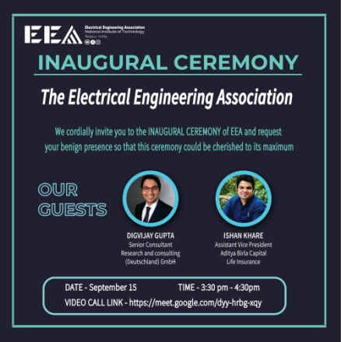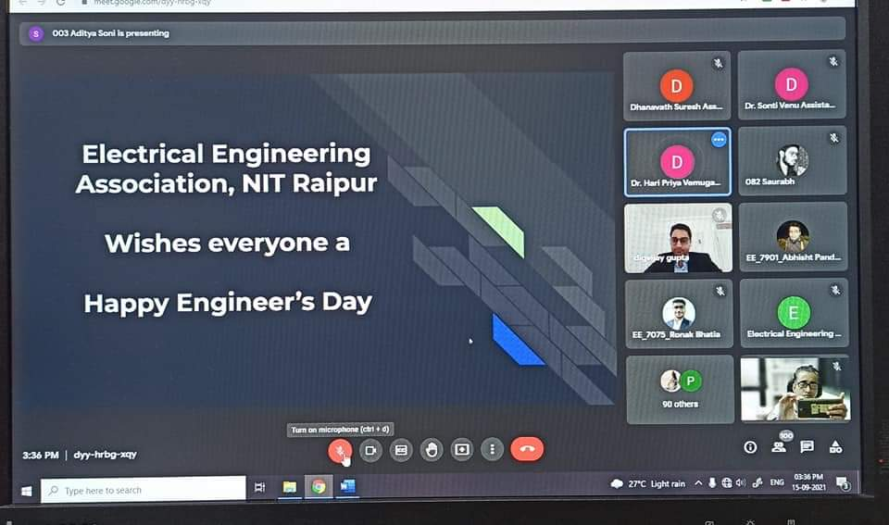

Electrical Engineering Association Activities - September 2021
- Guest lecture Under Institute lecture series –
In the part of EDUTAINMENT ACTIVITES Department of Electrical Engineering organized the first lecture under the prestigious program of “Institute Lecture Series” of NITRR. Dr. Sanjeevikumar Padmanaban, Professor, Aarhus University, Denmark delivered expert lecture on the topic "State of Art Fuel Cell Vehicular Power Train" on 18th September 2021.
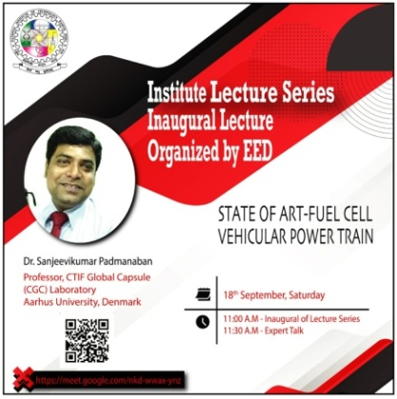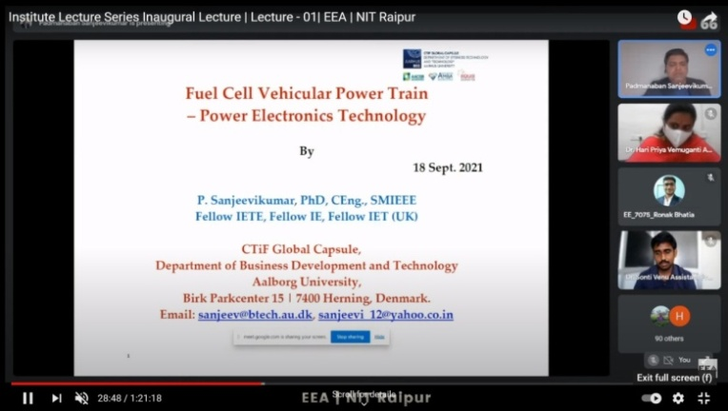
Expert Details:
- In the era of Power converters, “Dr. Sanjeevikumar Padmanaban” is an eminent researcher and profound expert at global level.
- Being academician, researcher, design engineer, administrator and project manager, he served various reputed organizations at National and International level.
Lecture Outcome:
- This activity is first of its kind being conducted to enhance the exposure of the faculty, students and scholars to global research.
- The question & Answer session of the lecture turned more interactive where interesting practical challenges are discussed with the participation of wide number of students.
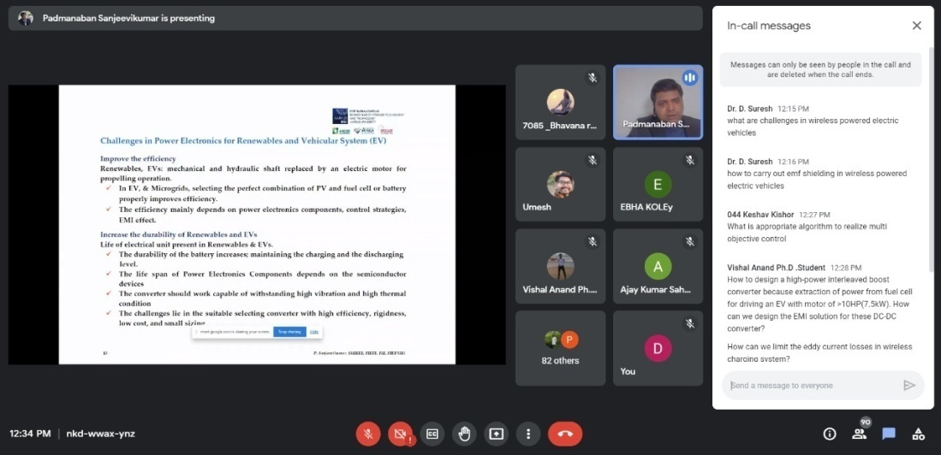
Electrical Engineering Association Activities – October 2021
1. Industrial lecture Series: Session-I
With a vision to promote students' potential ability to understand and apply the concepts of electrical engineering, The Electrical Engineering Association (EEA), Department of electrical engineering initiated "Industrial lecture series". This program aims to conduct interactive Industrial expert lectures on various course topics of ongoing semester of Electrical Engineering, underlining their challenges in practical implementation.
In this Regard, an expert talk under Industrial lecture series: Session- I is organized for seventh semester students to enhance their practical knowledge on the course High voltage Engineering. Mr. Haridal Singh, Retired GM Bhilai Steel Plant and General Manager (Automation), SAIL, IISCO Steel Plant, delivered the expert lecture on Testing of High Voltage Equipments in Session-1 of "Industrial lecture series" on 20-10-2021 from 12.00 PM to 1.35 PM.
https://meet.google.com/zub-gzgw-xuv

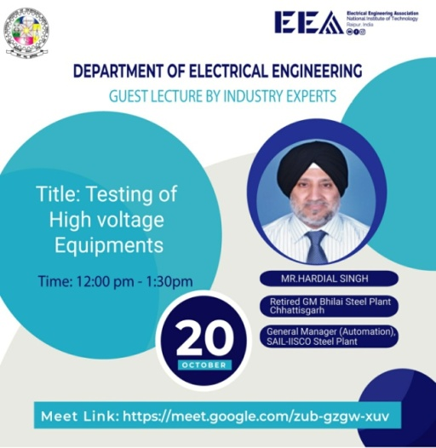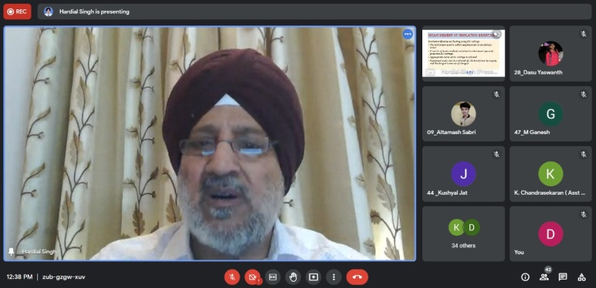
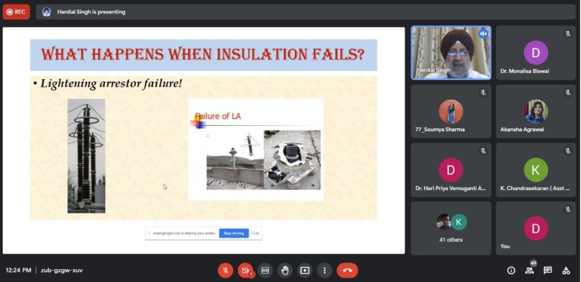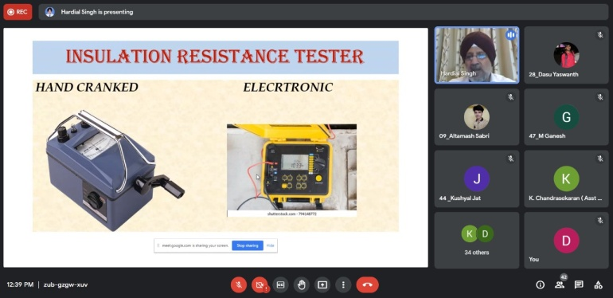

Electrical Engineering Association Activities – October 2021
2. Industrial lecture Series: Session-II
With a vision to promote students' potential ability to understand and apply the concepts of electrical engineering, The Electrical Engineering Association (EEA), Department of electrical engineering initiated "Industrial lecture series". This program aims to conduct interactive Industrial expert lectures on various course topics of ongoing semester of Electrical Engineering, underlining their challenges in practical implementation.
In this Regard, an expert talk under Industrial lecture series: Session-II is organized for third semester students to enhance their practical knowledge on the course Power Systems. Dr. D. P. Kothari delivered the expert lecture on powers systems – Yesterday, Today and Tomorrow Testing of High Voltage Equipment in Session-1 of "Industrial lecture series" on 20-10-2021 from 12.00 PM to 1.35 PM.
https://drive.google.com/file/d/1FH_MunAFJySLUc2FmmXPr-40J19uFdwH/view?usp=sharing

