Dr. Lalit Singh, Scientist, NPCIL-BARC
Dr. Abhishek Sharma, IIIT Raipur
Dr. Vivek Tiwari, IIIT Raipur
Dr. Mitul Kumar Ahirwal, MANIT Bhopal
Dr. Sri Khetwat Sarith, MANIT Bhopal
Dr. J Satya Eswari, NIT Raipur
Dr. B.K.Singh, NIT Raipur
Dr. Aakanksha Sharaff, NIT Raipur

Speakers

Chief Patron
Dr. A. M. Rawani, Director, NIT Raipur

Patron
Dr. (Mrs.) Shubhrata Gupta, Dean (R&C), NIT Raipur

Coordinators
Dr. Neelamshobha Nirala
Assistant Professor, NIT Raipur
Dr. Aakanksha Sharaff
Assistant Professor, NIT Raipur

Address for Correspondence
Dr. Neelamshobha Nirala
Department of Biomedical Engineering
NIT Raipur (CG)-492 010
Email: neelanir.bme@nitrr.ac.in
Contact No.: +91-6232089917

Dr. Aakanksha Sharaff
Department of Computer Science and Engineering
NIT Raipur (CG) - 492 010
Email: asharaff.cs@nitrr.ac.in
Contact No.: +91-8817813946
Online Registration Link for this STTP:

- Systematic development of practical programming skills
- Lectures by eminent experts & alumni of BARC/IIITs/ NITs
- Useful for beginners as well as advanced learners
- Covers a wide range from introduction to Applications of Machine learning in practical problems, research & analysis
- Demonstration of various algorithms through software like MATLAB/Python/R programming

One Week
Short Term Training Program
On
Machine Learning: from Theory to Modelling
  - 23rd – 27th September, 2019
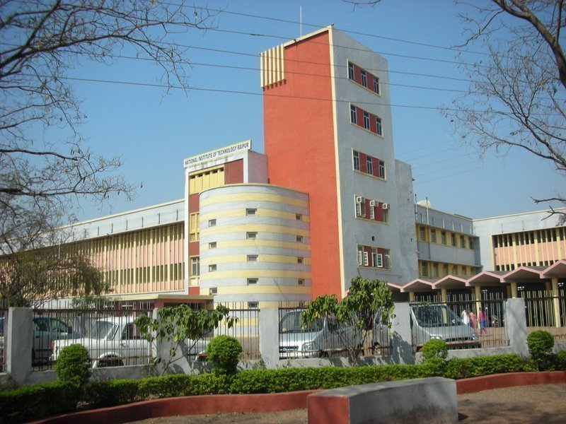
Organized by
Department of Biomedical Engineering
And
Department of Computer Science & Engineering

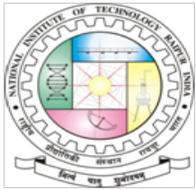

National Institute of Technology
Raipur-492 010 (Chhattisgarh)

National Institute of Technology
Raipur-492 010 (Chhattisgarh)

Highlights of the program

Selection

Since the number of seats is limited to 40, the selection will be made on first cum first basis. However, the preference will be given to the outside participants. Intimation regarding selection will be sent to the candidates by e-mail as per the schedule. Certificates will be issued to the participants only after attending the complete course. No TA/DA will be paid to the participants.

Participants | Amount(in INR)
UG students | 750/-
PG/PhD students | 1000/-
Internal faculty members | 1500/-
Outside faculty/Delegates | 2000/-
Applications in prescribed format along with the registration fee in the form of Demand Draft/ Banker’s cheque drawn in favor of “Director, NIT Raipur” payable at Raipur, must reach the coordinator on or before 20th September, 2019. Registration fee includes registration kit during the program. Fee is non-refundable. Certificates will be issued to the participants only after attending the complete course.
Important Dates:
Last Date of Registration: 20th September, 2019
STTP Date: 23rd – 27th September, 2019

Objective of the course

This event is aimed at imparting knowledge and training on the basics of machine learning using available software (MATLAB/python/R). This program will be beneficial to students at undergraduate level, post graduate level, research scholars and young researchers who intend to practice/begin research in machine learning. This Short Term Training Program is proposed to give an exposure to students and researchers to understand the concepts of Machine learning and their implementation in software. By the end of the program they will be able to understand the basics of machine learning, its real time implementation on MATLAB/Python/R and its applications on various fields.

- Introduction to Machine Learning (ML): tools and techniques
- Types of classification, supervised and un-supervised learning.
- kNN, k-means algorithms
- Decision Tree
- Support Vector Machine
- Regression
- Clustering
- Dimensionality reduction techniques
- Optimization techniques
- Hands-on training on various ML algorithms

- UG/PG/Ph.D. students from any stream
- Faculty members/Researchers

About the Institute

National Institute of Technology, Raipur situated in the capital of Chhattisgarh, has proven to be "avant-grade” in the field of science and technology over past few decades in this region. With sweet memory of foundation ceremony by our president Hon'ble Dr. Rajendra Prasad on 14th September, 1956. The Institute started with two departments namely Metallurgical and Mining Engineering. Later the inauguration of the Institute building was done by our Prime Minister Hon'ble Pt. Jawahar Lal Nehru on 14th March 1963. From 1st December 2005, the institute has become the National Institute of Technology. The institute is 5 km from the Raipur railways station and 18 km from airport on NH-6, the Great Eastern Road.

The Department of Biomedical Engineering and Department of Computer Science and Engineering came into existence in the year 2003 and 2000 respectively. BME & CS&E department are the study, research and work place of approximately 550 students from the 28 states across India. The departments provides an outstanding research environment and offers academic program leading to the award of B.Tech. M.Tech (CS&E) and Ph.D. degree.

Department of Biomedical Engineering, National Institute of Technology, G.E. Road, Raipur–492010, (C.G.), India.

Registration fees Details (in INR)

Topics to be covered
About the Department

Venue

Who should attend?
REGISTRATION FORM
One Week
Short Term Training Program (STTP)
On

Machine Learning: from Theory to Modelling
23rd – 27th September, 2019
Organized by
Department of Biomedical Engineering
National Institute of Technology, Raipur, C.G.
Full Name (Block Letter): ……………………………………………………………………….
…………………………………….………………………………………………………………
Name of College/Institution/Organization:
…………………………………….………………………………………………………………
…………………………………….………………………………………………………………
Qualification: ……………………………………………………………………………………
Designation: ……………………………………………………………………………………..
Address: …………………………………….………………………………………………………………
…………………………………….………………………… …………………………………………
Pin code: Phone No. /Mobile No.: E-mail:
Do you need accommodation: (Yes/ No):
I have enclosed the registration fee of Rs…………………by D.D. No ……………………………..
Dated……………….in favour of “Director, NIT, Raipur” payable at SBI, GCET Branch, Raipur.
Place: Signature of the participant
Date:
Duly filled registration form must reach to the “Department of Biomedical Engineering, NIT-Raipur-492010”, before last date of receipt of registration form by post/by hand along with registration fee (DD/Banker’s cheque).

