NATIONAL WORKSHOP
on
“Recent Trends of Computational Statistics and Operations Research
in Science and Engineering”

December 9-13, 2019

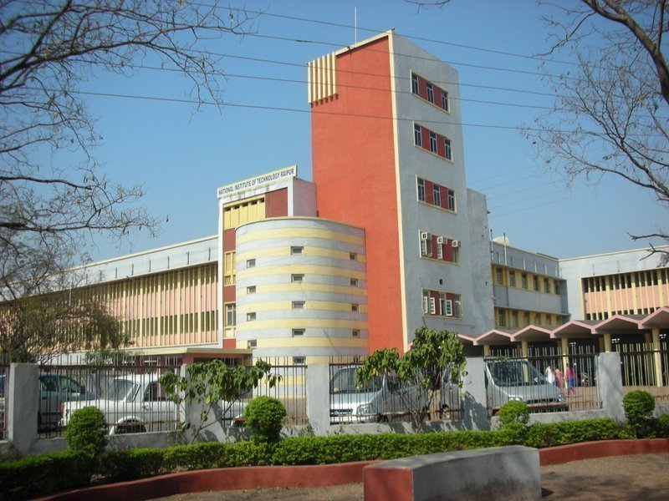

Organized by

Department of Mathematics

National Institute of Technology Raipur
Raipur-492 010, Chhattisgarh, India

Chief Patron
Dr. M. Rawani, Director, NIT Raipur

Patron
Dr. S. Gupta, Dean (R&C), NIT Raipur

HOD
Dr. A. K. Sinha, Mathematics, NIT Raipur

Coordinators
Dr. Sujit Kumar Samanta
Dr. Anup Kumar Sharma

Organizing Committee Members
Dr. D. Mishra, NIT Raipur
Dr. S. N. Raw, NIT Raipur
Dr. M. K. Prasad, NIT Raipur
Dr. N. K. Thakur, NIT Raipur
Dr. Deepmala Sharma, NIT Raipur

Address for Correspondence
Dr. Sujit Kumar Samanta
Assistant Professor
Department of Mathematics
NIT Raipur (CG)-492 010
Email: sksamanta.maths@nitrr.ac.in
Contact No.: 09575509285

Dr. Anup Kumar Sharma
Assistant Professor
Department of Mathematics
NIT Raipur (CG) - 492 010
Email: aksharma.maths@nitrr.ac.in
Contact No.: 09199454963

NATIONAL WORKSHOP
on
“Recent Trends of Computational Statistics and Operations Research
in Science and Engineering”

December 9-13, 2019

REGISTRATION FORM
Name: ………………………………………
Designation: …………………..……………
Organization: ………………………………
Qualification: ……………………………….
Gender:……………………………………..
Correspondence Address: ………….……
……………………………………..............
Mobile No.……………………….……........
E-Mail: ………………………..…………….
Registration Fee: Paid herewith in the form of
Cash/DD/online payment mode
Amount ……………….................................
Transaction ID: ..........................................
Date ………………………………………..
Name of the Bank……………………..……
Accommodation Required: Yes / No
(Availability on payment basis)

Date: Place:

For online Registration go through the following link: https://forms.gle/CVQhXspyfAVR2MnS7
- Demand draft should be in favour of Director, National Institute of Technology Raipur, payable at Raipur.
- Online payment should be made to the following Account No.: 38027633250, Name: Director, NIT Raipur, IFSC: SBIN0002852
- Photocopy of registration form may be used.

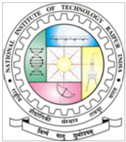

About the Institute:

National Institute of Technology Raipur (Formerly Government Engineering College Raipur), situated in the capital of a newly incepted state of Chhattisgarh, has proven to be "avant-grade’’ in the field of science and technology over past few decades in this region. With sweet memory of foundation ceremony by our president Hon’ble Dr. Rajendra Prasad on 14th September 1956. The institute started with two departments namely Metallurgical and Mining Engineering. Later the inauguration of the Institute building was done by our Prime Minister Hon'ble Pt. Jawahar Lal Nehru on 14th March 1963. From 1st December 2005, the institute has become the National Institute of Technology. It is well connected with Mumbai, Delhi, Hyderabad, Kolkata, Bhopal, Ahmedabad, Bangalore, Chennai and Chandigarh by regular flights and is on the main Howrah-Mumbai railway route. The institute is 5 km from the Raipur railways station and 18 km from airport on NH-6, the Great Eastern Road.

About Department:

The Department of Mathematics came in existence since 1956. The department provides an outstanding research environment and offers academic program leading to the award of Ph.D. degree. Apart from this, department taking care of Mathematical input to all undergraduate and postgraduate courses in Engineering and Computer Science Applications.

Venue:

D -2 (2nd Floor),Virtual Classroom,
NIT Raipur (CG) – 492 010, INDIA
Topics to be covered:
- Special Discrete and Continuous Probability Distributions
- Sampling Distributions
- Point and Interval Estimations
- Testing of Hypotheses
- ANOVA
- Advanced Sampling Techniques
- Regression Analysis
- Stochastic Process
- Advanced Optimization Techniques
- Multi-Criteria Decision-Making and Applications in Business
- Stochastic Optimization
Targeted Participants:
- Academicians
- Industry Professionals
- Students and Research Scholars
Registration Fee Details (in INR):

Participants | Amount (in Rs)
Students | 1000
Faculty | 2000
Industry Delegates | 2500

Applications in prescribed format along with the receipt of online registration fee payment must reach the coordinators on or before 6th December 2019. Registration fee includes registration kit, tea and lunch during the program. Fee is non-refundable. Since the number of seats is limited to 25, the selection will be made on first cum first serve basis and intimation will be sent to the candidates by email as per the schedule. Certificates will be issued to the participants only after attending the complete course. No TA/DA will be paid to the participants.

Objective:

The course is to provide up-gradation of knowledge and skills for research scholars / faculties / scientists involved in active research. The course will provide in depth exposure to them. The lectures will be delivered by distinguished experts in their field. The five days short term course will include lectures, special case studies on the areas of computational statistics and operations research with applications in science and engineering as well as a hand on practical experience in Excel and R. In addition, it will also feature invited lectures from eminent scientists and academicians.

Theme/Scope:
The five days National Workshop on “Recent Trends of Computational Statistics and Operations Research in Science and Engineering” will bring together a group of experts in Statistics and Operation Research in NIT Raipur. This is a scientific and technological character event and aim to bring together professionals working in AICTE approved engineering colleges and persons work in Industry / R & D Organizations, students and researchers of engineering and related sciences. The scope of the presentations will include theoretical development of statistics, operation research and its application in Engineering, Science and Technology, and any interdisciplinary combination that is not yet standard in the field. This program will introduce Excel and R for beginners which is helpful for writing programming. The National Workshop will also address all-level researchers, and is aimed to help shaping future research directions and creating opportunities for new interdisciplinary collaborations.

