CHIEF PATRON
Dr. A. M. Rawani
Director, NIT Raipur

PATRON
Dr. Shirish Verma
Dean Academics, NIT Raipur

CHAIR PERSON
Dr. N. D. Londhe
HOD Electrical, NIT Raipur

COURSE CO-ORDINATORS
DR. SHUBHRATA GUPTA
DR. ANAMIKA YADAV

ORGANIZING COMMITTEE
Dr. R, N, Patel, Assoc. Professor, NIT Raipur
Dr. S. Jain, Associate Professor NIT Raipur, Dr. S. Pattnaik, Assist Professor NIT Raipur, Dr. B. Bag Assistant Professor NIT Raipur, Dr. L. K. Sahu, Assist Professor NIT Raipur.

Address for Correspondence
Department of Electrical Engineering,
National Institute of Technology, Raipur, C.G.
E-mail: ayadav.ele@nitrr.ac.in, sgupta.ele@nitrr.ac.in
Telephone (M) : 91-9425852654

Short Term Training Programme on
‘Recent Trends in Power Electronics, Power System and Renewable Energy System (RTPEPSRES-2020)’

REGISTRATION FORM
Name: ………………………………………
Designation: …………………..……………
Organization: ………………………………
Qualification: ……………………………….
Correspondence Address: ………….……
……………………………………..............
..................................................................
Tel. (O) ………………. (R) …..……….......
(M) …………………………….……........
E-Mail: ………………………..…………….
Registration Fee is paid in the form of Cash/DD/Online Transfer
Amount ………………...........................
No...............................Date ……………
Name of the Bank……………………..……
Accommodation Required: Yes / No

Date: Place:

Signature
Note:
Demand draft should be made in favour of Director, National Institute of Technology Raipur, payable at Raipur.
Photocopies of registration form may be used.

Short Term Training Programme
on
‘Recent Trends in Power Electronics, Power System and Renewable Energy System (RTPEPSRES-2020)’

From
February 17-21, 2020
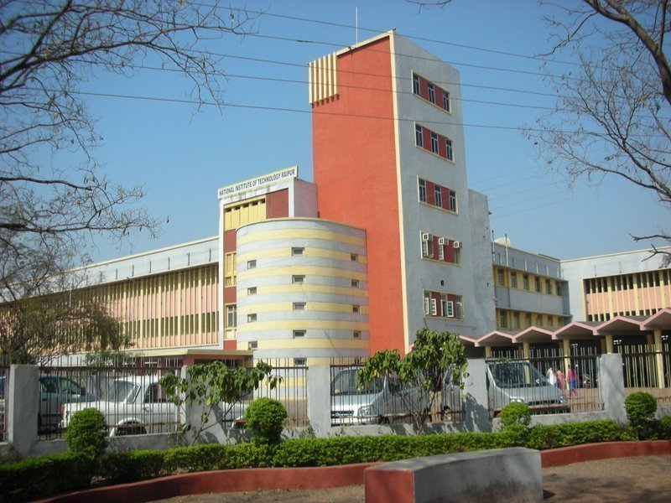
Organized by

Department of Electrical Engineering

National Institute of Technology
Raipur-492 010 (Chhattisgarh)

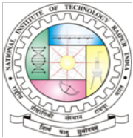

About the Institute:

National Institute of Technology Raipur situated in the capital of Chhattisgarh, has proven to be "avant-grade' in the field of science and technology over past few decades in this region. With sweet memory of foundation ceremony by our president Hon'ble Dr. Rajendra Prasad on 14th September 1956. the institute started with two departments namely Metallurgical and Mining Engineering. Later the inauguration of the Institute building was done by our Prime Minister Hon'ble Pt. Jawahar Lal Nehru on 14th March 1963. From 1st December 2005, the institute has become the National Institute of Technology. It is well connected with Mumbai, Delhi and all metro cities by regular flights and is on the main Howrah-Mumbai railway route. The institute is 5 km from the Raipur railways station and 18 km from airport on NH-6, the Great Eastern Road.

About Department:

- The Department of Electrical Engineering came in existence since 1958.
- National level research projects are sanctioned.
- National and International research papers are contributed by all faculty members every year.
- Offers undergraduate as well as postgraduate programs.
- The department provides an outstanding research environment and offers academic program leading to the award of Ph.D. degree.

Venue:

Department of Electrical Engineering
NIT Raipur (CG) – 492 010, INDIA
Topics to be covered:
The program will be conducted in an interactive environment providing greater scope for discussion. Emphasis will be on a highly participative style of learning.

• Power Electronics in Smart Grids
➢ Transmission Systems
➢ Distribution Systems
➢ Micro-Grids
➢ Renewable Energy Integration
➢ Energy Management & Storage
➢ Grid Security and optimization
➢ Advanced Control Systems
• Power Electronics in Power System
• Power Electronics in Electric Vehicles
➢ Sensor-less Techniques
➢ Artificial Intelligence Techniques
➢ Multilevel Inverters
➢ Battery Charging Systems
➢ Latest Motor Drive Technologies

Registration Fee Details (in INR):
Participants | Amount (in Rs)
Students | 1000/-
Faculty | 2000/-
Industry Delegates | 2500/-

Application in the prescribed format with registration fee in the form of DD/NEFT/RTGS drawn in favor of “Director, NIT Raipur” must reach the coordinator on or before 15 February 2020. Candidates may send scanned copy of the registration form along with scanned of DD/NEFT/RTGS transaction. Hard copy may then be submitted on the day of registration. Registration fee includes registration kit, tea and lunch during the program. Fee is non-refundable. Certificates will be issued to the participants only after attending the complete course.

Objectives:

The objective of this programme is to train the faculty members, research scholars, young scientists, and post graduates students of various organizations. The objectives of program are to provide a platform for interaction and exchange of ideas on recent trends in the field of power system and protection techniques.
Theme/Scope:

The importance of power electronics has grown over the years due to several factors. Power electronics is interdisciplinary in nature and is used in a wide variety of area of Electric Drives, Power System, Power Quality in Power Systems and Renewable Energy systems etc. This STTP is designed to address applications of power electronics in the industry and to encourage various professionals/research scholars/ academicians towards research and for their Academic Quality Improvement too. This course will offer a unique opportunity to the all colonize in the relevant topics to come closer through theoretical sessions and more number of laboratory-based experiments/ demonstrations.
……………………………………..
Targeted Participants
Students, research scholars and faculties of
Engineering and basic sciences of educational institutes and employees of industries

REGISTRATION FORM

Short Term Training Programme
on
‘Recent Trends in Power Electronics, Power System and Renewable Energy System (RTPEPSRES-2020)’
From
February 17-21, 2020
Organized by

Department of Electrical Engineering
National Institute of Technology
Raipur-492 010 (Chhattisgarh)

Full Name (Block Letter): ……………………………………………………………………….
…………………………………….………………………………………………………………
Name of College/Institution/Organization:
…………………………………….………………………………………………………………
…………………………………….………………………………………………………………
Qualification: ……………………………………………………………………………………
Designation: ……………………………………………………………………………………..
Address:
…………………………………….………………………………………………………………
…………………………………….………………………………………………………………
…………………………………….………………………………………………………………
Pin code:
Phone No./Mobile No.:
E-mail:
Do you need accommodation: (Yes/ No):
I have enclosed the registration fee of Rs…………………by Transaction ID ………………
Dated………………. (To the account of Director - Account No.: 38027633250, IFSC: SBIN002852, SBI, Raipur).

Place:
Date:

Signature of the participant

Soft copy of the Duly filled registration form along with the receipt of registration fee Payment must be sent to the email of coordinator :- ayadav.ele@nitrr.ac.in, Department of Electrical Engineering, NIT-Raipur on or before 15.02.2020.

