Ist International Conference
On
“Separation & Purification Techniques: Environmental Applications”
From
19^{th–} 20thJanuary 2024

REGISTRATION FORM:
Name: _______________________________
Designation: __________________________
Organization: _________________________
Qualification: _________________________
Address: _____________________________
_____________________________________
_____________________________________
_____________________________________
Contact No.: __________________________
Email: _______________________________
Bank Name: __________________________
IFSC Code: ___________________________
Trnx. No.: ___________ Date: ____________
Amount: __________ Mode: _____________
Date: ___________ Place: _______________

Signature
Note: Registration must be made through online payment only.
- Account Name: Director NIT Raipur
- Account No.: 38027633250
- IFSC Code: SBIN0002852
- Bank Name: State Bank of India
- Branch Name: NIT Branch
- Address: G.E. Road, Raipur (C.G.) 492010

CHIEF PATRON
Prof. N.V. Ramana Rao
(Director, NIT Raipur)

PATRON
Dr. Prabhat Diwan
(Dean (R&C), NIT Raipur)

CO-PATRON
Dr. (Mrs.) A.B. Soni
(Professor, Chemical Engineering, NIT Raipur)

CHAIRMAN
Dr. Amit Keshav
(Head, Chemical Engineering, NIT Raipur)

SECRETARIES
Dr. J. Anandkumar
Dr. C. Thakur
Dr. M.S. Gaikwad
(Chemical Engineering, NIT Raipur)
*************************************************************************
ORGANIZING COMMITTEE MEMBERS
Dr. B. Mazumdar | Dr. P.K. Chaudhari
Dr. V.K. Singh | Dr. A.K. Poonia
Dr. Manivannan | Dr. P. Ghosh
*************************************************************************
ADVISORY COMMITTEE MEMBERS
- Dr. Dependu Saha, Widener University, USA
- Dr. A.Tanksale, Monash University, Australia
- Dr. A.K. Dalai, University of Saskatchewan, Canada
- Dr. Rama Rao Karri, Universiti Teknologi Brunei
- Dr. G. Pugazhenthi, IIT Guwahati
- Dr. B. C. Meikap, IIT Kharagpur
- Dr. V.C. Srivastava, IIT Roorkee
- Dr. Saravannan Pichiah, IIT (ISM) Dhanbad
- Dr. Arthanareeswaran, NIT Trichy
- Dr. V. Sivasubhramanian, NIT Calicut

Ist International Conference
On
“Separation & Purification Techniques: Environmental Applications”

From
19^{th –} 20th January 2024
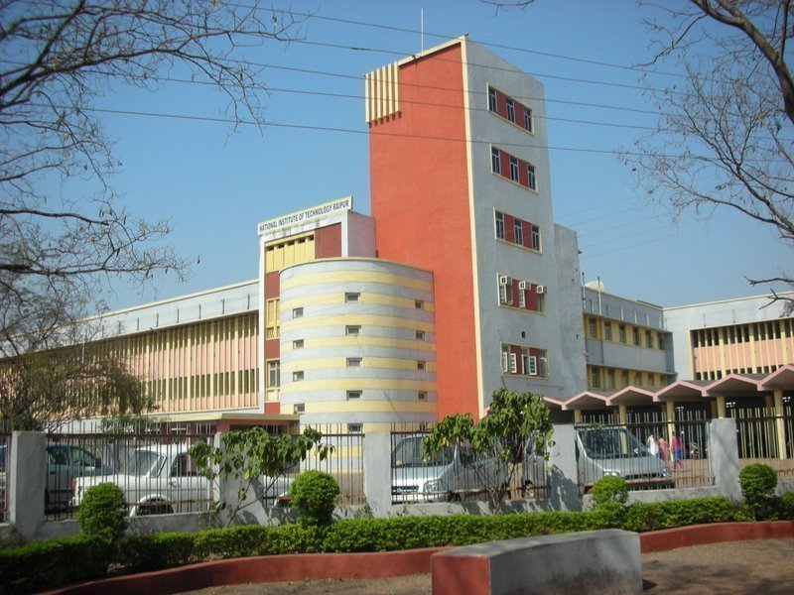
Organized by

Department of Chemical Engineering
National Institute of Technology Raipur
Raipur-492 010 (Chhattisgarh)
◙◙◙◙◙◙◙◙◙◙◙◙◙◙◙◙◙◙◙◙◙◙◙◙◙◙◙◙◙
ADDRESS FOR CORRESPONDENCE
Dr. J. Anandkumar, Dr. C. Thakur &
Dr. M.S. Gaikwad
(Organizing Secretaries)
Department of Chemical Engineering
National Institute of Technology Raipur
Email: anandj.che@nitrr.ac.in, cthakur.che@nitrr.ac.in, msgaikwad.che@nitrr.ac.in
Contact No.:+91-6395953499, +91-9669715209
◙◙◙◙◙◙◙◙◙◙◙◙◙◙◙◙◙◙◙◙◙◙◙◙◙◙◙◙◙

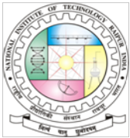

OBJECTIVES
The aim of this program is to provide a valuable and important platform for interaction, exchange of knowledge and innovative ideas on recent research trends in separation & purification techniques used for various environmental applications in the field of Chemical Engineering, Chemistry, Biotechnology, Environmental Science & Engineering, Pharmaceutical etc. to the experts from industry, R&D sector and reputed academic institutes and their the faculty members, research scholars, young scientists, postgraduate and undergraduate students.
SCOPE OF THE CONFERENCE
This International Conference on Separation & Purification Technologies is organized to provide a thorough exposure to the recent and future research trends in the field of Separation and Purification Techniques for various environmental applications. Distinguishing features of this programme include keynote lectures by the distinguished experts from world renowned organizations. This conference will provide opportunities to faculty members, engineers, students, industrial people and other researchers to share the latest advancements in the areas of Chemical & Energy Engineering, Chemistry, Biotechnology, Environmental Science and Technology, Pharmaceutical and other relevant fields. This conference will also have series of oral presentation sessions with different themes of separation and purifications techniques.
CONFERENCE PUBLICATION & AWARDS:
- The selected full-length papers will be published as Book chapters and in the reputed Scopus/SCI indexed Journals. (The details of the publications will be update soon on the conference website.)
- The best oral papers and posters will be awarded in closing function of the conference.
THEME TO BE COVERED
- Advances in Membrane Separation Processes
- Modern Physio-Chemical & Bio-Separation & Purification Processes for Environmental Management
- Advanced Purification methods used in the Industries
- Separation Techniques for Energy Management
- Applications of Nanotechnology & Polymer Science for Environmental remediation
- Materials for carbon capture, storage and utilization.
- Utilization of waste materials for circular economy.
- Applications of Analytical Equipments (AAS, GC, GC-MS, FTIR, HPLC, Rheometer etc.) related to Environmental applications
- Other topics related to the theme of the Conference
REGISTRATION FEES DETAILS
Research Scholars, UG & PG Students | Rs. 1500/-
Faculty & R&D persons | Rs. 2500/-
Industrial Delegates | Rs. 4000/-
Foreign Delegates | 150 USD

Note: (i) Above fee is including the GST and (ii) Fooding & lodging is not included.

VIRTUAL MODE
- Virtual presentation will be only allowed for the delegates from outside the India. Conference-certificates will be sent by email.
- Conference schedule and other details will be updated in conference website.
IMPORTANT DATES
- Conference dates: 19th – 20thJanuary 2024
- Abstract Submission: 05th Dec, 2023
- Acceptance Notification: 20th Dec, 2023
- Registration Deadline: 30th Dec, 2023
- Full length Paper submission: 10th Feb, 2024

ABOUT THE INSTITUTE
National Institute of Technology Raipur situated in the capital of Chhattisgarh, has proven to be "avant-grade' in the field of science and technology over past few decades in this region. With sweet memory of foundation ceremony by our president Hon'ble Dr. Rajendra Prasad on 14th September 1956 the institute started with two departments namely Metallurgical and Mining Engineering. Later the inauguration of the Institute building was done by our Prime Minister Hon'ble Pt. Jawahar Lal Nehru on 14th March 1963. From 1st December 2005, the institute has become the National Institute of Technology. It is well connected with Mumbai, Delhi and all metro cities by regular flights and is on the main Howrah-Mumbai railway route. The institute is 5 km from the Raipur railways station and 18 km from airport on NH-6, the Great Eastern Road.

ABOUT DEPARTMENT
The Chemical Engineering Department was established in the year 1962 under the aegis of Government Engineering College, Raipur (now National Institute of Technology Raipur, Raipur). The Department is offering undergraduate course (B.Tech. in Chemical engineering), one post-graduate course (M.Tech. in Energy & Environment) and Ph.D. programme (Research in various Chemical Engineering & Allied areas). UG course (B.Tech. in Chemical Engineering) has been accredited by NBA.

VENUE
NIT RAIPUR, G.E. ROAD, RAIPUR-492010, CHHATTISGARH, INDIA

