Chief-Patron
Prof. A. M. Rawani
Director, NIT Raipur

Prof. S.G. Deshmukh
Officiating Director PDPM IIITDM Jabalpur, and Director, ABV-IIITM, Gwalior

Patron
Prof. (Mrs.) S. Gupta
Dean (R&C), NIT Raipur

Chairman
Prof. S. Verma
Dean (Acad.), NIT Raipur

Conveners and Coordinators
Dr. R. K. Chaurasiya
Asst. Prof., NIT Raipur

Dr. A. Naugarhiya
Asst. Prof., NIT Raipur

Prof. P N Kondekar
PDPM IIITDM Jabalpur

Address for Correspondence
Dr. A Naugarhiya (Asst. Prof.)
(Electronics and Telecommunication)
Email: anaugarhiya.etc@nitrr.ac.in
Contact No. +91 9826 55 1906

Department of Electronics and Telecommunication
National Institute of Technology, Raipur
G.E. Road, Raipur, India-492 010
Website: www.nitrr.ac.in

Faculty Development Programme

on

“MACHINE LEARNING and IoT”

11th – 15th March, 2019

REGISTRATION FORM FORMAT
(Please use separately attached Registration form for sending the application)
Name: ………………………………………
Designation: …………………..……………
Category (Gen/OBC/ST/SC)………………
Gender (Male/Female)……………………..
Organization:…………………………… … Qualification: ………………………………. Correspondence Address: ………….…… …………………………………….............. Tel(M) …………………………….……....... Type of participation:...............................
E-Mail: ………………………..………… Registration Fee is paid in the form of DD in favors of DIRECTOR, NIT RAIPUR payable at SBI Raipur. Amount of Rs.……......... DD No............... Date………… Name of the Bank …………
Accommodation Required: Yes / No
Date:…………. Place:………………
Signature……………..
Forwarding Authority…………………….
Note:
- Demand draft should be made in favour of Director, NIT Raipur , payable at Raipur.

Faculty Development Programme

on

“MACHINE LEARNING and IoT”

11th – 15th March, 2019

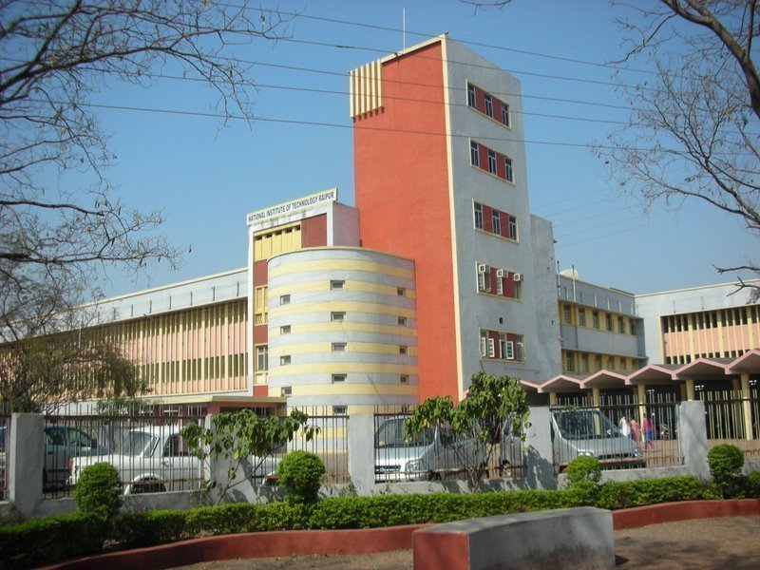

Jointly Organized by

Dept. of Electronics and Telecommunication Engineering
&
Electronics & ICT Academy, PDPM IIITDM Jabalpur



at
National Institute of Technology
Raipur-492 010 (India)

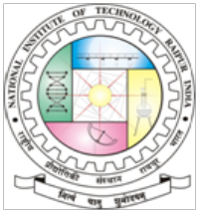

About the Institute:
National Institute of Technology Raipur situated in the capital of Chhattisgarh, has proven to be "avant-grade' in the field of science and technology over past few decades in this region. With sweet memory of foundation ceremony by our president Hon'ble Dr. Rajendra Prasad on 14th September 1956, the institute started with two departments namely Metallurgical and Mining Engineering. Later the inauguration of the Institute building was done by our Prime Minister Hon'ble Pt. Jawahar Lal Nehru on 14th March 1963. From 1st December 2005, the institute has become the National Institute of Technology. It is well connected with Mumbai, Delhi and all metro cities by regular flights and is on the main Howrah-Mumbai railway route. The institute is 5 km from the Raipur railways station and 18 km from airport on NH-6, the Great Eastern Road.

About Departments:
The Dept. of Electronics and Telecommunication came into existence in 1985. The department aims be national leaders in imparting quality education, carrying out research and technology development. The department provides an outstanding research environment and offers academic program leading to the award of B. Tech, M Tech and Ph.D. degrees.

About the E & ICT Academy, PDPM IIITDMJ:
Ministry of Electronics and Information Technology, Government of India has instituted seven Electronics and ICT Academies with one academy at IIITDM Jabalpur with the primary objective preparing manpower for two important missions - ‘Digital India’ and ‘Make in India’. The Academy aims at the design and implementation of scalable training programmes in niche areas of electronics and ICT for the development of required knowledge base, skills and tools to unleash the talent of Indian population. The Academy at IIITDMJ will partner with IIITM Gwalior, MANIT Bhopal, and IIT Indore run high quality specialized courses for faculty, students and unemployed graduates.
Topics to be covered:

- Introduction to Machine Learning (ML).
- Introduction of IoT and Application in Smart city.
- WSN application in IoT
- Recent Research Trends in Field of VLSI & Micro-nano Technologies
- ASIC Design Flow.
- Types of classification, supervised and un-supervised learning.
- Statistical pattern recognition techniques-SVM, KNN, Naïve Bayes classifier etc.
- Dimensionality reduction techniques-PCA, LDA etc.
- Deep learning.
- Optimization techniques (PSO, GA, LJ Optimization etc.)
- Applications of ML and Optimization in data mining and pattern recognition.
- Hands-on training on applications of ML algorithms and EDA Tools.
- Magnetic Induction Communication for non-conventional media application for development of smart city.

Important Dates
- Last date of receipt of application: 25.02.2019
- Notification of selection on or before (by Email): on or before: 26.02.2019
Registration Details (in INR):
Registration is as under:

Rs.1000/-for all people from Academics.
Rs.500/- for SC/ST candidates.
Rs.3000/- for persons from Industry.
.
Scanned or Hard copy of Application form in the prescribed format must reach the coordinator (Dr ALOK NAUGARHIYA) on or before 25th Fab, 2019. Registration includes registration kit, course material, lunch and tea & snacks.

Venue:
NIT Raipur (CG) – 492 010, INDIA
Objectives:
Machine Learning (ML) and IoT play a significant role in the modern engineering and information processing systems. It is a rapidly growing field.
The Machine Learning is an essential part of pattern recognition, object detection and classification, clustering, data mining and speech recognition etc. In addition, IoT has important significance over machine learning in application of smart city.
The aim of this FDP is to provide an exposure to both basics and recent advances in Machine Learning and IoT to the teaching and research community associated with the departments of Electronics, Electrical, Computer Science, IT, MCA, Bio Medical etc. The trainings will cover pattern recognition and data mining fields specifically.
Speakers:
Expert lectures will be delivered by the Faculty members of the various branches from the institute and from outside NIT Raipur. Hands-on sessions are suitably designed to supplement classroom discussions using suitable software.
Eligibility:
Participation in this FDP is open to the faculty members, engineers, researchers, and other executives working on diverse fields of engineering such as IT, electronics, computer, electrical, instrumentation, biomedical, biotechnology, mechanical engineering, etc.
Selection:
The seats are limited to 30 candidates. The preference will be given to the participants on first-come, first-served basis. However, faculty participants would get priority over other participants. Intimation regarding selection will be sent to the candidates by email as per the schedule. No TA/DA will be paid to the participants. Boarding/lodging may be provided to few participants in institute hostels, subjected to availability (If required, Accommodation chargers approx-1000/- additional). Lunch, snacks and tea will be provided during the session breaks.

