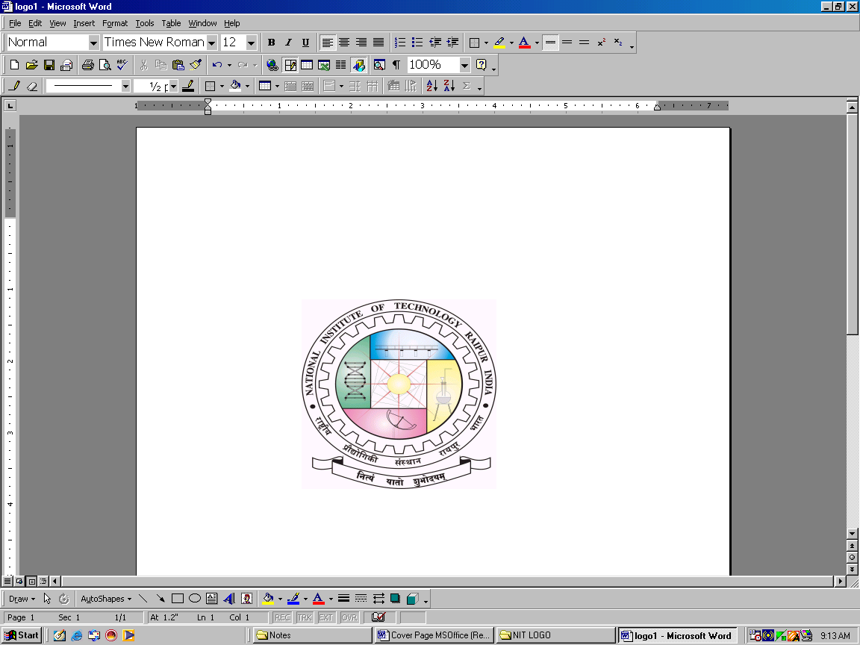
Phone (O): (0771) 2253413
Phone (R): (0771) 6540784
Website: www.nitrr.ac.in
E-Mail: chiefwarden.girls@nitrr.ac.in
NATIONAL INSTITUTE OF TECHNOLOGY
(Institute of National Importance)
G.E. Road, Raipur - 492010 (C.G)

No./NITRR/CW (G)/……….. Raipur, Dt. …………………..

OFFICE OF THE CHIEF WARDEN (GIRLS’)
Notice for Admission of B.Tech. / B.Arch. (III, V & VII Sem)/ M.Tech. / MCA (III & V Sem) / Students (2022-2023)
Girls’ Hostels
Please Note:
- Only regular students can apply for hostel accommodation.
- Seats are limited in the Girls’ hostels.
- Institute reservation norms will be followed in hostel seat allotment and PH candidates will be given preference in their respective categories.
- Merit list will be based on CPI score. In case of same CPI , SPI will be considered.
- Students from local & nearby areas of Raipur will get the least preference in hostel seat allotment due to limited availability of seats.
- Hostel seats will be allotted branch wise on pro rata basis.
- For the III, V & VII semester hostel admission the mark sheet of I , III & V semester respectively should be uploaded as a supporting document.

How to apply:
- The interested regular students can fill the Google form using the following link.
https://forms.gle/NTjWK6wgmig7zY6P8
- The last date for submitting applications (using Google form only) is 01 July, 2022. The applications must be supported by the relevant documents, such as
(i) Passport Size Color Photographs
(ii) Receipt of the Institute Admission 2021-22.
(iii) Category Certificates (If applicable)
(iv) Vaccination Certificates
(v) PH Certificate (If applicable)

For any other queries related to hostel admission, students may contact to the following persons during working hours only (10:00 AM to 6:00 PM, Monday to Saturday).
- Mrs. Deepika Sharma (Matron, Hostel Indrawati) : 7987365212
- Ms. Geetanjali Sahu (Matron, P.G.Hostel) : 7000227938
- Mrs. Haripriya (Matron, Hostel Mahanadi) : 8319137011
- Mr. Rupendra Dewangan (Asst. Grade - III) : 8878397585
- Mr. Shesh Narayan Banchhor (Computer Operator) : 8959946267

- If found any discrepancy in the form, hostel admission will be automatically cancelled.

Chief Warden Girls’
NIT, Raipur

