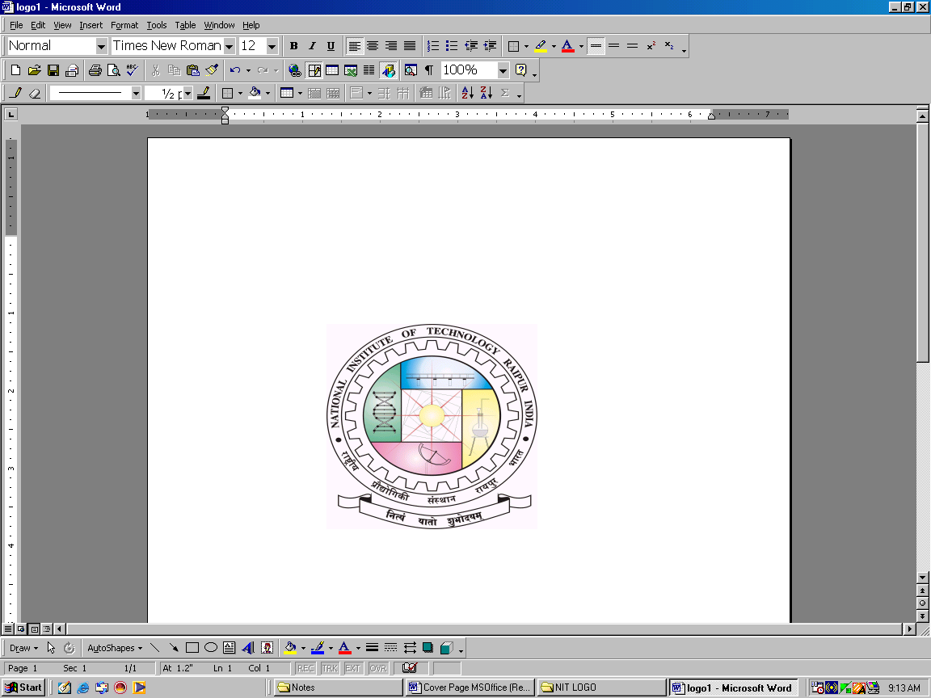
jk"Vªh; ÁkS|ksfxdh laLFkku jk;iqj
NATIONAL INSTITUTE OF TECHNOLOGY RAIPUR
(An Institute of National Importance)
G.E. Road, Raipur - 492010 (C.G)
Phone: (0771) 4270619, Email: chiefwarden.girls@nitrr.ac.in, Website: www.nitrr.ac.in

No./NITRR/CW (G)/2022/…………… Dated: - 15/07/2022
NOTICE HOSTEL ADMISSION 2022-23 (GIRLS' HOSTEL)
- The provisional list for admission in Girls’ hostels has been uploaded. The hostel fee including mess advance for session 2022-23 is to be deposited (only State Bank I-Collect ) as per details in the following link http://www.nitrr.ac.in/downloads/acad_cal/2022/Hostel%20fees%20structure%20Boys%20&%20Girls%202022-23.pdf

- The last date for deposition of the fee is 25.07.2022. If the student fails to deposit the hostel fee within above date, her admission will be cancelled.

- If it is found at any stage that the student has provided wrong information in admission process, her admission will be cancelled and only mess advance and caution money will be refunded.

- The students will have to produce the proof of payment of institute and hostel fee while getting admission in hostel.
- Part III of hostel fee is to be deposited in spring semester for which date will be notified later.

- Girls are advised to pay the respective fee in correct account numbers (only State Bank I-Collect) as indicated in the link, otherwise, admission in hostel will not be considered.

Chief Warden Girls’
National Institute of Technology,
Raipur (C.G)

Copy To-
- Registrar, NIT, Raipur.
- Dean, Students’ Welfare, NIT, Raipur.
- Prof. I/c Website, with request to upload the notice and hostel admission list on website.
- Deputy Registrar (F&A).
- All Hostel Wardens, Girls.
- Notice Board of all Hostels.
- Asst. Reg. Student Section.
- Branch Manager, S.B.I. NIT Branch, Raipur for necessary action.

