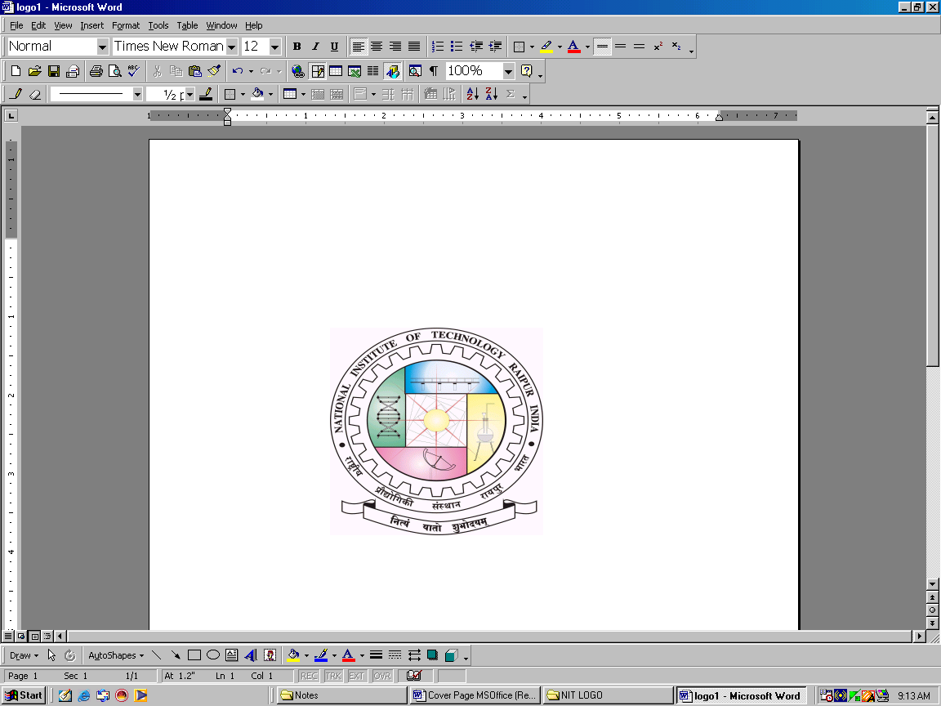
OFFICE OF THE CHIEF WARDEN GIRLS’
Website: www.nitrr.ac.in
Email: chiefwarden.girls@nitrr.ac.in

NATIONAL INSTITUTE OF TECHNOLOGY
(Institute of National Importance)
G.E. Road, Raipur - 492010 (C.G)

No./NITRR/CW (G)/_______ Raipur, Date _________/07/2022

CIRCULAR

Request from many girl-students, not allotted hostel have been received to Chief Warden (Girls’) office.
After discussion with Honorable Director Sir, director sir has decided to continue to provide accommodation (without any furniture); temporarily into E-type faculty quarter (instead of allotting them to faculty) on merit basis.
So we will be providing some more seats/accommodation for girls students, ‘WITH NO FURNITURE’ (Mess facility will be available in Hostel ‘Indrawati’/'Mahanadi') on merit basis only. Interested girls must apply with an under taking/consent to accept the No furniture condition and submit the hard copy of hostel form*to Chief Warden office (in Girls Hostel 'Indrawati') by 12thAug 2022, 6:00 PM.

* Hostel Form can be received from Chief Warden Office.

Chief Warden (Girls’)
NIT, Raipur

