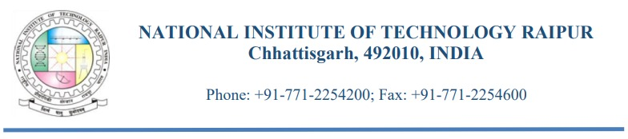
Advertisement for the Post of JRF in Department of Metallurgical and Materials Engineering, NIT Raipur
Applications are invited for the following assignment in a purely time-bound project undertaken in the Department of Metallurgical and Materials Engineering, National Institute of Technology, Raipur, Chhattisgarh, India

The details are enlisted JRF are as follows:
Name of the position: | Junior Research Fellow (JRF)
Project Title: | Development of Low-ppm Ammonia sensors using NiO/CeO₂ heterostructured nanofibers
Funding Agency: | DST, Science & Engineering Research Board (SERB), Govt. of India, New Delhi-110070
Duration of the Project | Project is in the extension stage and (approx..) 3 Months left for its completion (Date of expiry: 06.03.2024).
Duration &  Emoluments: | Total (approx.) Three months. Salary: Rs.31,000/- per month as JRF
Essential  qualifications: | M.E/ M. Tech/M.S in Metallurgical/Materials Science/Metallurgical & Materials Engineering, Mechanical, Chemical , Ceramic, Production, Biotechnology, Biomedical Engineering or M.Sc. in Basic science (Physics, Chemistry etc.) or relevant disciplines with selection in one of the following exams:  CSIR-UGC NET including LS / GATE / JEST / JGEEBILS /  ICMR JRF Entrance examination / ICAR-AICE qualification/  DST/DBT/DAE/DRDO/DOS/MHRD qualifying examination.
Date, time, and place  of Interview (Tentative) : | 20.12.2023, 12 pm, NIT Raipur, Department of MME, NIT Raipur
How to apply: | Filled application form with signature, along with complete relevant documents should reach to Dr. Sudip Kumar Sinha, Project Investigator, Asst. Professor, Deptt. of Metallurgical and Materials engineering, NIT Raipur, Raipur, C.G.-492010 and send the soft copy of applications preferably by email to sksinha.mme@nitrr.ac in prior to interview date.

Terms and Conditions:

1. The above position is purely temporary, and continuation of the fellowship is subject to satisfactory performance and review after each year.
2. Candidates are required to appear for the interview with photocopy of the application form, two passport size photos, curriculum vitae,
testimonials and all relevant original certificates with a one set of self-attested photocopies of the certificates.
3. No TA/DA is permissible for appearing for interview.
4. JRF post is purely temporary, the candidate shall not claim regular appointment at this Institute, as the post is co-terminus with the project.
5. Canvassing in any form will disqualify the candidature and the appointment shall be co-terminus with the project.

How to apply:

The application form will be hosted at NIT Raipur website (www.nitrr.ac.in). Candidates should send their CV along with the application form to Dr. S.K.Sinha (sksinha.mme@nitrr..ac.in) one or before 16 -th December, 2023. Selected candidates will be called for interview on 20 th December 2023, 12.00 PM onwards. Mode of the Interview would be in Hybrid (online/offline both) based upon the request of the candidate. A separate online link would be sent to shortlisted candidates, if required. Candidates should bring all the original documents for the interview in the Department of Metallurgical and Materials Engineering, NIT Raipur.

For technical information of the project, the candidate may contact the principle.
Investigator at the following address:

Name : Dr. Sudip Kumar Sinha

Address :

Department of Metallurgical & Materials Engineering,
NIT Raipur, GE Road, Raipur, Chhattisgarh- 492010, India,
E-mail: sksinha.mme@nitrr.ac.in
Contact No: 91-9340437917

Copy to – Webmaster to upload the advertisement in the institute website.

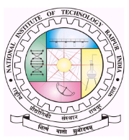
DEPARTMENT OF METALLURGICAL & MATERIALS ENGINEERING
NATIONAL INSTITUTE OF TECHNOLOGY, RAIPUR
Phone: 0771-2254200, Fax : 0771 – 2254600

DST-SERB CORE Research Grant Project entitled “Development of Lo-ppm Ammonia sensors using NiO/CeO₂ heterostructured nanofibers”

Application for Junior Research Fellow (JRF)
1. Name _____________ ______________________ ____________

(Surname) (First Name)
2. Address

Phone: Fax No.: Email ID:
3. Date of Birth :
4. Nationality :
5. Sex :
6. Complete Academic Record (Starting from X standard)
Degree and Specialization | University/Institute | Year of Completion | Division
7. Areas of Interest
8. Publications/conference participation (National/International):
9. Research experience apart from M.Tech/M.Sc research:
9. Any Other Relevant Information :
Signature of Applicant Date :
Place :

Note: Attach a photocopy (soft version) of the relevant documents with the application

