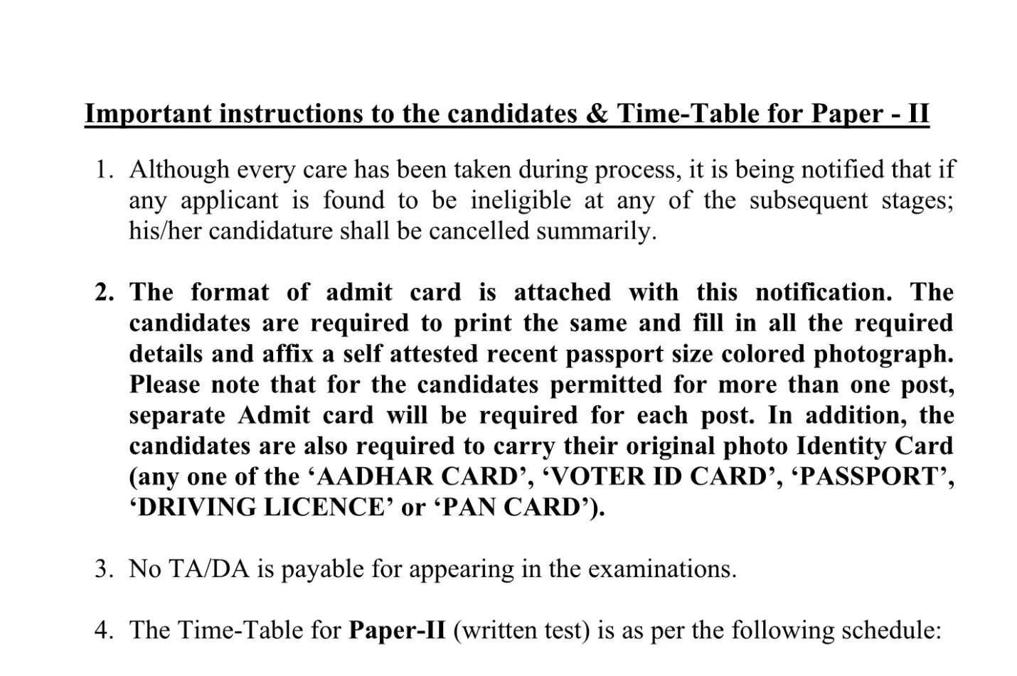

TIME TABLE OF PAPER II FOR THE POST OF TECHNICAL ASSISTANT(REGULAR/CONTRACT), TECHNICIAN (REGULAR/CONTRACT), SENIOR TECHNICIAN (REGULAR), JUNIOR ENGINEER
S.NO. | DATE | TIME | NAME OF DEPARTMENT | NAME OF POST
1 | 02.09.2021 | 08:00 AM To 09:00 AM | CIVIL | TECHNICAL ASSISTANT (REGULAR)
1 | 02.09.2021 | 11:30 AM To 12:30 PM | MECHANICAL | TECHNICAL ASSISTANT (REGULAR)
1 | 02.09.2021 | 02:00 PM To 03:00 PM | ELECTRONICS | TECHNICAL ASSISTANT (CONTRACT)
1 | 02.09.2021 | 04:30 PM To 05:30 PM | CHEMICAL | TECHNICAL ASSISTANT (CONTRACT)
2 | 03.09.2021 | 08:00 AM To 09:00 AM | COMPUTER CENTRE | SENIOR TECHNICIAN
2 | 03.09.2021 | 11:30 AM To 12:30 PM | ELECTRONICS | SENIOR TECHNICIAN
2 | 03.09.2021 | 02:00 PM To 03:00 PM | CIVIL | JUNIOR ENGINEER
2 | 03.09.2021 | 02:00 PM To 03:00 PM | ELECTRICAL | JUNIOR ENGINEER
2 | 03.09.2021 | 04:30 PM To 05:30 PM | ELECTRICAL | TECHNICAL ASSISTANT (REGULAR)
2 | 03.09.2021 | 04:30 PM To 05:30 PM | BIOMEDICAL | TECHNICAL ASSISTANT (REGULAR)
3 | 04.09.2021 | 08:00 AM To 09:00 AM | BIOTECHNOLOGY | SENIOR TECHNICIAN
3 | 04.09.2021 | 11:30 AM To 12:30 PM | BIOMEDICAL | SENIOR TECHNICIAN
3 | 04.09.2021 | 02:00 PM To 03:00 PM | CHEMICAL | SENIOR TECHNICIAN
3 | 04.09.2021 | 04:30 PM To 05:30 PM | ELECTRICAL | SENIOR TECHNICIAN

S.NO. | DATE | TIME | NAME OF DEPARTMENT | NAME OF POST
4 | 05.09.2021 | 08:00 AM To 09:00 AM | INFORMATION TECHNOLOGY | SENIOR TECHNICIAN
4 | 05.09.2021 | 11:30 AM To 12:30 PM | MECHANICAL | SENIOR TECHNICIAN
4 | 05.09.2021 | 02:00 PM To 03:00 PM | MINING | SENIOR TECHNICIAN
4 | 05.09.2021 | 04:30 PM To 05:30 PM | CIVIL | SENIOR TECHNICIAN
4 | 05.09.2021 | 04:30 PM To 05:30 PM | COMPUTER SCIENCE | SENIOR TECHNICIAN
4 | 05.09.2021 | 04:30 PM To 05:30 PM | METALLURGY | SENIOR TECHNICIAN
5 | 06.09.2021 | 08:00 AM To 09:00 AM | CHEMISTRY | TECHNICAL ASSISTANT (CONTRACT)
5 | 06.09.2021 | 11:30 AM To 12:30 PM | COMPUTER SCIENCE | TECHNICAL ASSISTANT (CONTRACT)
5 | 06.09.2021 | 02:00 PM To 03:00 PM | ARCHITECTURE | TECHNICAL ASSISTANT (REGULAR)
5 | 06.09.2021 | 02:00 PM To 03:00 PM | ARCHITECTURE | TECHNICAL ASSISTANT (CONTRACT)
5 | 06.09.2021 | 04:30 PM To 05:30 PM | PHYSICS | TECHNICAL ASSISTANT (CONTRACT)
6 | 07.09.2021 | 08:00 AM To 09:00 AM | ARCHITECTURE | TECHNICIAN (REGULAR)
6 | 07.09.2021 | 11:30 AM To 12:30 PM | CHEMICAL | TECHNICIAN (REGULAR)
6 | 07.09.2021 | 02:00 PM To 03:00 PM | ELECTRICAL | TECHNICIAN (REGULAR)
6 | 07.09.2021 | 02:00 PM To 03:00 PM | CHEMISTRY | TECHNICIAN (CONTRACT)
6 | 07.09.2021 | 04:30 PM To 05:30 PM | INFORMATION TECHNOLOGY | TECHNICIAN (REGULAR)
6 | 07.09.2021 | 04:30 PM To 05:30 PM | CIVIL | TECHNICIAN (CONTRACT)
7 | 08.09.2021 | 08:00 AM To 09:00 AM | COMPUTER CENTRE | TECHNICIAN (CONTRACT)
7 | 08.09.2021 | 11:30 AM To 12:30 PM | METALLURGY | TECHNICIAN (CONTRACT)
7 | 08.09.2021 | 02:00 PM To 03:00 PM | MINING | TECHNICIAN (CONTRACT)

