Department of Mathematics NIT Raipur

- A two days National Conference on “Mathematical Modeling, Methods and Computation in Science and Engineering (MMMCSE–2019), October 19-20, 2019” Organized by the Department of Mathematics, NIT Raipur.

A two days National Conference on “Mathematical Modeling, Methods and Computation in Science and Engineering (MMMCSE–2019)” was conducted successfully on October 19-20, 2019. This Conference was organized by Department of Mathematics, NIT Raipur and Dr. Nilesh Kumar Thakur and Dr. Sharada Nandan Raw are organizing secretary of this conference. The objective of this conference was to bring together the researchers working in various fields of applied and computational mathematics for enriching their research applications to different branches of Science, Engineering and Technology. The Conference was formally inaugurated by Chief Guest, Dr. P. P. Chakravarthy, Professor and Head, Department of Mathematics, VNIT Nagpur. The Chairman of the conference and Head of the Department Mathematics Dr. Arvind Kumar Sinha and Professor Dr. R. P. Pathak sir have shared the dais during the inaugural function. Dr. P. P. Chakravarthy has delivered an invited talk on “Numerical solution of singularly perturbed delay differential equations on an adaptive grid”. Dr. R. P. Pathak, NIT Raipur has also enlightened on the importance of the Conference. In the conference, 29 participants have taken the registration and 21 research papers have been presented in the area of Mathematical Modeling, Methods and Computation in Science and Engineering.
The participants were from all over the India as Bhubaneswar (Odisha), Chhanai (Tamilnadu), IIIT Naya Raipur, Surat (Gujrat), Amarkantak (MP), Cuttak (Odisha), Gaya (Bihar), Midanapoore (West Bangal), Raipur, Durg , Bhilai and from many more places. The papers were presented on the field of mathematical modeling on Wavelet Theory, Boundary Layer Problems, Ecological System, Diffusion Driven Instability in Animal Coats, Graph theory and Sociogram, Financial Mathematics, Inventory Problems, Rough set theory, Complete ordered metric space, probability distributions, Application of ODE and PDE in real world problems, Optimization problems, Fixed point theorems, General integral transforms, Finite element methods, Convergence of splitting matrices and many more.
The conference has planned in three sessions out of which two sessions were parallel on the first day after invited talk. On the second day an invited talk was given by person from industry: Mr. Akanand Dewangan Director (Production), Kaps Foods India Pvt. Ltd. Raipur on “Become an entrepreneur” followed by session 3. The Best paper award was given for each three sessions. The certificates were distributed to participants during Valedictory function. The details of certificates are attached with this report.

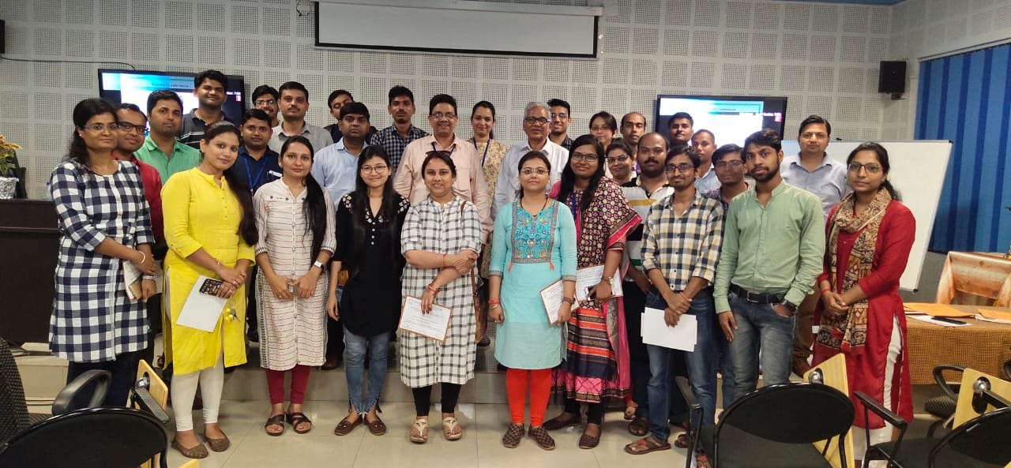
Group Photo of National Conference on “Mathematical Modeling, Methods and Computation in Science and Engineering (MMMCSE–2019) (October 19-20, 2019)” Organized by the Department of Mathematics.

- Dr. Sharada Nandan Raw has delivered the expert lectures in One Week Faculty Development Programme “Application of Numerical Methods and Statistical Techniques in Engineering” organised by Rajiv Gandhi Proudyogiki Vishwavidyalaya Bhopal (M.P) at Department of Mathematics, LNCT Bhopal during September 23-27, 2019.

- National Workshop on “Recent Trends of Computational Statistics and Operations Research in Science and Engineering, December 9-13, 2019” Organized by the Department of Mathematics, NIT Raipur.

A five days National Workshop on “Recent Trends of Computational Statistics and Operations Research in Science and Engineering” was conducted successfully during December 9-13, 2019. This workshop was organized by Department of Mathematics, NIT Raipur. Dr. Sujit Kumar Samanata and Dr. Anup Kumar Sharma are the organizing coordinators of this workshop. The objective of this workshop was to bring together the researchers working in various fields of Computational Statistics and Operations Research for enriching their research applications to different branches of Science, Engineering and Technology. The Workshop was formally inaugurated by Chief Guest, Dr. R. K. Jana, Assistant Professor IIM Raipur. The Head, Department Mathematics, Dr. Arvind Kumar Sinha and Professor Dr. R. P. Pathak have shared the dais during the inaugural function. Dr. A. K. Sinha and Dr. R. P. Pathak, NIT Raipur has also enlightened on the importance of the Workshop. Total 27 participants have taken the registration for this workshop.

The participants were from all over the India as Institute of Mathematics and Applications, Bhubaneswar, Odisha, Cuttak (Odisha), Kalinga University Raipur, Pt. Ravishukla University (Raipur), ICFAI University Raipur, Madhubani (Bihar), and Research Scholar, Department of Architecture NIT Raipur. An invited talk was given by a person from industry: Mr. Akanand Dewangan Director (Production), Kaps Foods India Pvt. Ltd. Raipur on “Industry Flow using Mathematics”. The certificates were distributed to participants during Valedictory function.
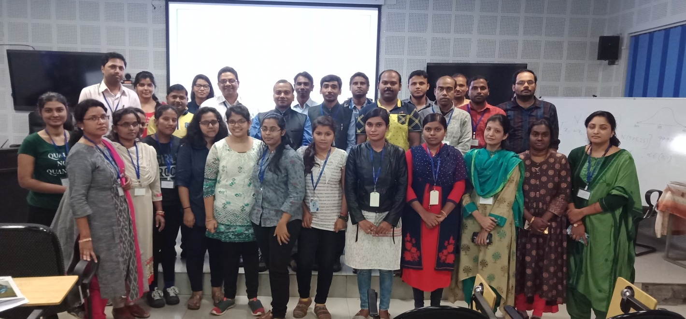
Group Photo of National Workshop on “Recent Trends of Computational Statistics and Operations Research in Science and Engineering”, (December 9-13, 2019) Organized by the Department of Mathematics.

