National Conference on “Recent Trends in Applied and Computational Mathematics” (July 20-21, 2019) Organized by the Department of Mathematics, NIT Raipur.

A two days National Conference on “Recent Trends in Applied and Computational Mathematics” was conducted successfully on July 20-21, 2019. This Conference was organized by Department of Mathematics, NIT Raipur. The objective of this conference was to bring together the researchers working in various fields of applied and computational mathematics for enriching their research applicable to different branches of Science, Engineering, and Technology. The Conference was formally inaugurated by Chief Guest, Dr. H. K. Pathak, Professor, PRSU, Raipur. HOD, Mathematics and chairman of Conference Dr. Arvind Kumar Sinha and Dr. R. P. Pathak have also shared the dais during the inaugural function. Dr. H K Pathak has delivered an invited talk on “Mathematical Modeling and Simulation Techniques - An Overview”. In the conference, 41 participants have taken the registration and 35 research papers have been presented in the area of applied and computational mathematics. The participants were from Hazaribag, Chatra–Jharkhand, Chapra – Bihar, Pilani – Rajasthan, Panduchery, Amarkantak – MP, Durg, Bhilai, and Raipur- CG. The papers were presented on the field of mathematical modeling, functional analysis, fuzzy and rough set theory, topological space, queuing theory, space technology, nonlinear oscillation, cryptography, numerical methods, mathematical ecology, dynamical system, integral transforms and many more. The conference has planned in three sessions out of which two sessions were parallel on the first day after invited talk. The second day an invited talk was given by Dr. Sahadeo Padhye, Associate Professor, Department of Mathematics, MNNIT Allahabad on “Cryptography from Classical to Modern” followed by session 3. The certificates were distributed to participants during Valedictory function in which three best paper awards (one for each session) have also been announced.

. 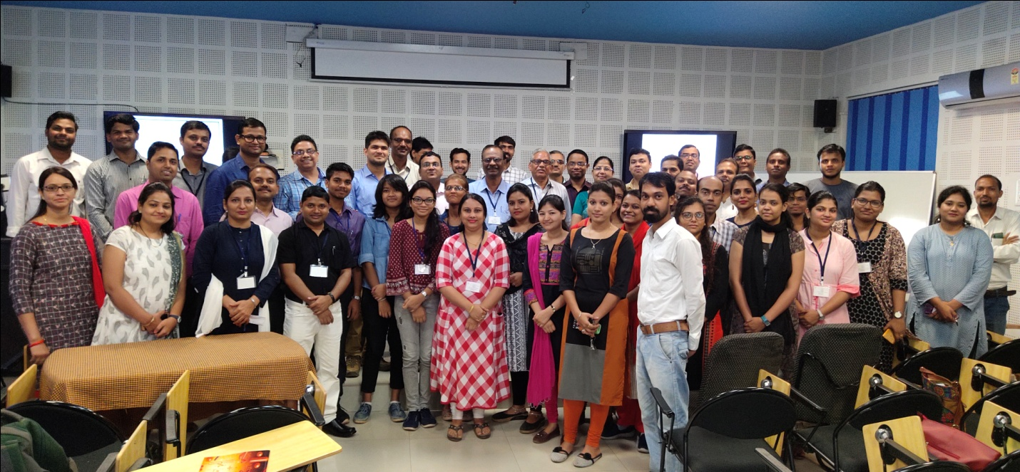
.

Group Photo of National Conference on “Recent Trends in Applied and Computational Mathematics” (July 20-21, 2019) Organized by the Department of Mathematics.

