Department of Mathematics
National Institute of Technology Raipur
The Department of Mathematics has successfully conducted five days National level Short Term Training Programme (STTP) on "Applied Mathematics using Python through Hands-on Experience" during February 10-14, 2020. The STTP has been started on 10thFebruary 2020 at 10:00 A.M. with inaugural function. The inaugural function was presided by Dr. R. P. Pathak, Visiting Professor, Department of Mathematics, NIT Raipur and the Chief Guest of the function was Dr. Satyanarayana Vollala, Assistant Professor, Department of Computer Science and Engineering, IIIT Naya Raipur. HOD Mathematics and Convener of the STTP Dr. A. K. Sinha and coordinator of STTP Dr. M. Krishna Prasad, have also shared the dais during the inaugural function. Welcome speech was given by Dr. Arvind Kumar Sinha, Course Convener.
Distinguished experts from NITs and IIITs have been invited for this STTP. They had delivered their valuable talks on Installation of Python software and Introduction to Python, data types and operators, control statements, standard I/O operations and functions, Modules and packages Numpy, Scipy and Matplotlib in the Python Programming ,Strings and lists, Tuples and Dictionaries, Solution of Algebraic and Transcendental equations, Interpolation and Curve fitting, Calculus, Numerical Methods of Differential Equations, The essence of Linear algebra using Python, Files and Exceptions, Solution of Algebraic and Transcendental equations using Python, Introduction of Regression analysis, Interpolation and Curve fitting using Python, Numerical Methods of Differential Equations using Python, Importance of Python in industry, Symbolic computations with Sympy.
In this STTP, 26 participants were registered from various Institutions like CSVTU Raipur, IIT Roorkee, Kalinga University Raipur, Institute of Mathematics and Application Bhubaneswar, IIT (ISM) Dhanbad, GGV, Koni Bilaspur, and NIT Raipur. The valedictory function of the STTP was conducted on 14th February, 2020. This function was presided by Dr. Arvind Kumar Sinha, Head of Department of Mathematics and Convener of the STTP and the Chief Guest for the function was Dr. N. D. Londhe, Associate Professor, Department of Electrical Engineering, NIT Raipur, and coordinator of STTP Dr. M. Krishna Prasad. The overall report of the short term training programme was given by Dr. A. K. Sinha, and vote of thanks was given by Dr. M. Krishna Prasad. All the participants had praised the organizing committee for smooth conduction of the STTP in their feedback. We hope all the participants have learned the Python programming and how it is used to solve real world problems. Overall the STTP was very much is successful.

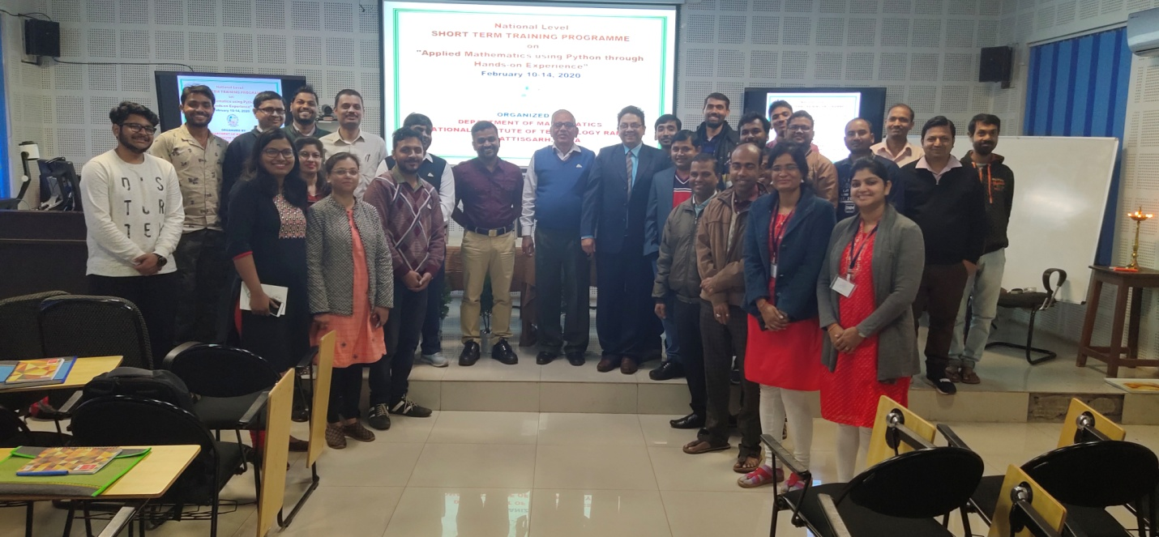

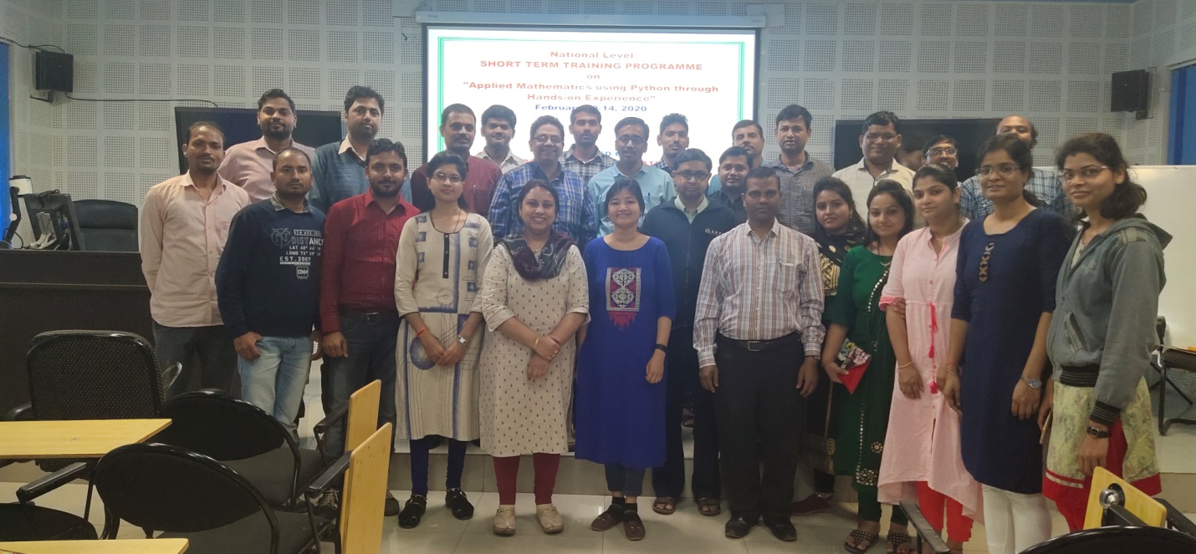

Dr. M. Krishna Prasad  (Coordinator) |  | Dr. Arvind Kumar Sinha  (Convener)

