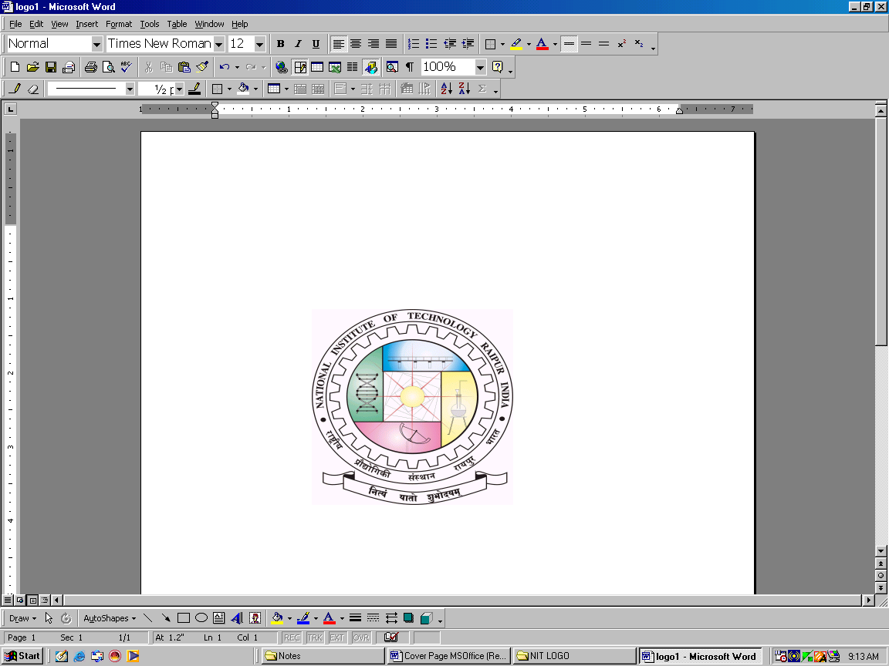
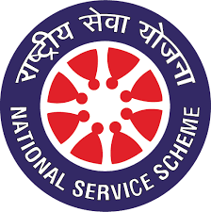
NATIONAL SERVICE SCHEME, NIT RAIPUR
G.E. Road, Raipur - 492010 (C.G)

Yearly report- 2018-2019

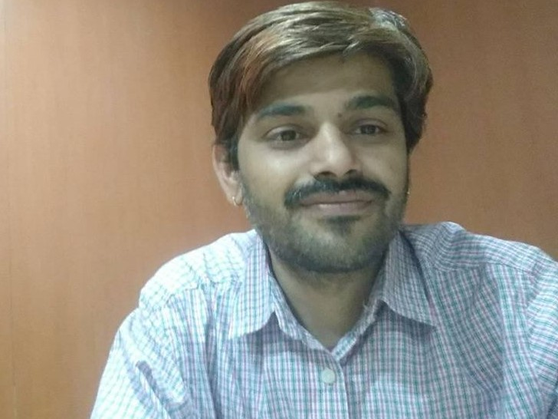  Dr. Govardhan Bhatt (Faculty in charge, team NSS) | Team National Service Scheme,NIT Raipur  The team National Service Scheme (NSS) worked (2018 -2019) with the aim of serving humane kind, developing the humanity and promoting patriotism in students of our college.The main motto of the team was connecting the our students with social-feelings.
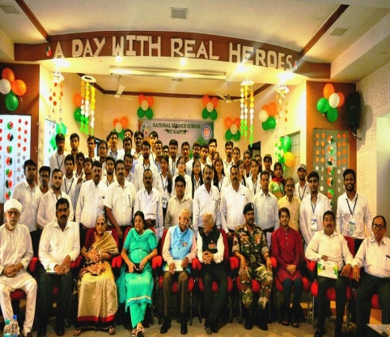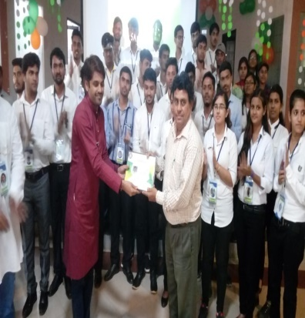 | A Day With Real Hero’s  Date- 13-September-2018  Motto- This event was organized to salute the defense person who scarified his life for our nation and promote the patriotism in our college.
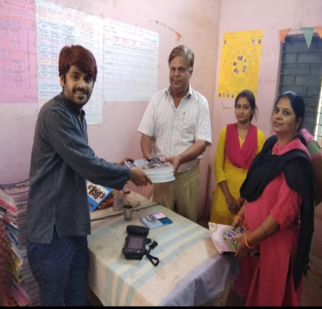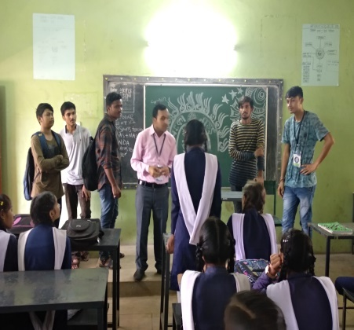 | School Visit  Date-29th September 2018  Motto- Team NSS visited Government high school and primary school In Guma village to give guideline for study, soft skills, board-exam and donate the 1200 books to primary school library.
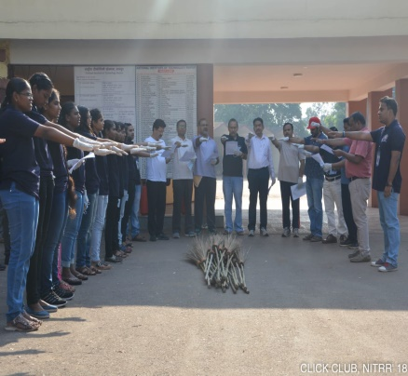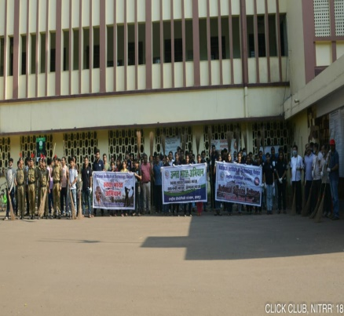 | Cleaning Campus  Date- 02-October-2019  Motto- Celebrate the Gandhi Jayanti with cleaning the our college campus
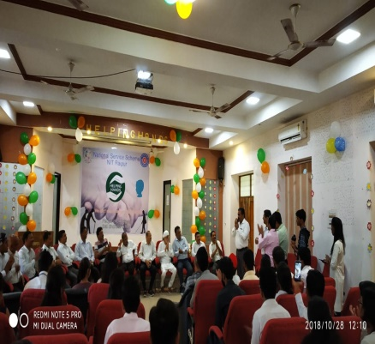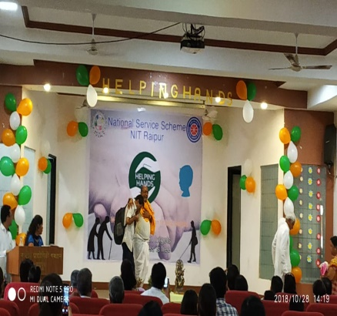 | Helping Hand  Date- 27th and 28th-October-2018  Motto- To help the orphan, Blind-child and old-age person who lives in old-age home.This event was mainly to promote the social activity in our college student.
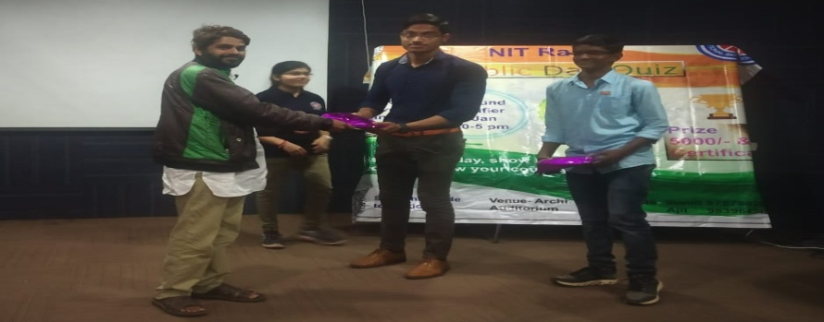 | Republic day Quiz  Date- 26th January 2019  Motto- To know about the nation and freedom- fighter.

